Lord of Life Lutheran Church

A Serving Community
God's work, our hands!
Rev. Rebecca Zielke, Pastor
Tim L. Elder, CAGO, Director of Music

16th Sunday after Pentecost
Sunday, September 13, 2026
10:15 a.m.

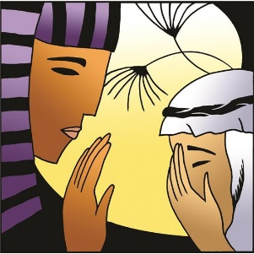

In today’s second reading Paul questions why we judge one another, since we all stand before the judgment of God. Yet we do sin against one another, and Jesus’ challenge that we forgive seventy-seven times reveals God’s boundless mercy. When we hear the words of forgiveness in worship and sign ourselves with the cross, we are renewed in baptism to be signs of reconciliation in the world.

550 North Broad Street 330-533-3531 Canfield, Ohio 44406 e-mail: lordoflife550@gmail.com

Welcome to Lord of Life!
Your presence in our midst is a blessing to us. We hope you find our worship service a prayerful and meaningful experience.

Visitors
If you are visiting with us this weekend, please consider signing our guest book located in our Gathering Space. An usher will be happy to assist you.

Holy Communion
All are welcome to partake in Communion regardless of Christian denomination. Please follow the usher’s direction to come forward to receive the bread from the Pastor and take a glass of wine from the tray. Dispose of the cup in the basket provided on the altar railing and return to your seat by the side aisle. Gluten free hosts are available upon request.

Worship notes
“ELW” refers to our hymnbook “Evangelical Lutheran Worship” which is the red hymnbook in the pew racks. Other hymns that may be included in our worship service, that do not appear in ELW, will be directly printed into the bulletin.

All items in bold print are responses spoken by the assembly.

Worship bulletin key: P = Pastor, L = Lector, C = Congregation.
Any other specific directions are notated in red throughout the bulletin.

The offering plate is located as you enter the worship space.

Restrooms
There are two sets of restrooms located in our building. The first, and closest, are found by exiting the sanctuary and turning to your right, down the hallway toward the coat room, and then turning right once again.
The second set, is located by exiting the sanctuary, turning right down the hallway toward the coat room and then turning left. Walk all the way down to the end of the hallway and they are located on your left.

GATHERING
The Holy Spirit calls us together as the people of God.
Announcements
Prelude Sinfonia Johann Sebastian Bach
Please stand as you are able.
Confession and Forgiveness
All may make the sign of the cross, the sign that is marked at baptism, as the presiding minister begins.
P Blessed be the holy Trinity, ☩ one God,
who pours love into our hearts
and healing upon the earth.
C Amen.

Confident that God justifies us by grace through faith,
let us confess our sin.

Compassionate God,
C we confess that we struggle to embody your goodness
in the world and in our own hearts.
Creation groans from overuse.
Jealousy and bitterness strain our relationships.
Indifference keeps us from seeking justice.
Divisions disrupt your call to show genuine love
to others.
Turn our hearts back to you.
Restore our world and reconcile us to one another.
Renew us to live as your holy people,
following the way of Jesus Christ.
Amen.

P Hear this good news:
We have peace with God through ☩ Jesus Christ,
in whom there is no condemnation,
but only forgiveness and the promise of eternal life.
Receive freely this healing gift of grace.
C Amen.

Gathering Hymn All Creatures, Worship God Most High ELW 835
Greeting
P The grace of our Lord Jesus Christ, the love of God and the communion of the Holy Spirit be with you all.
C And also with you.

Glory to God
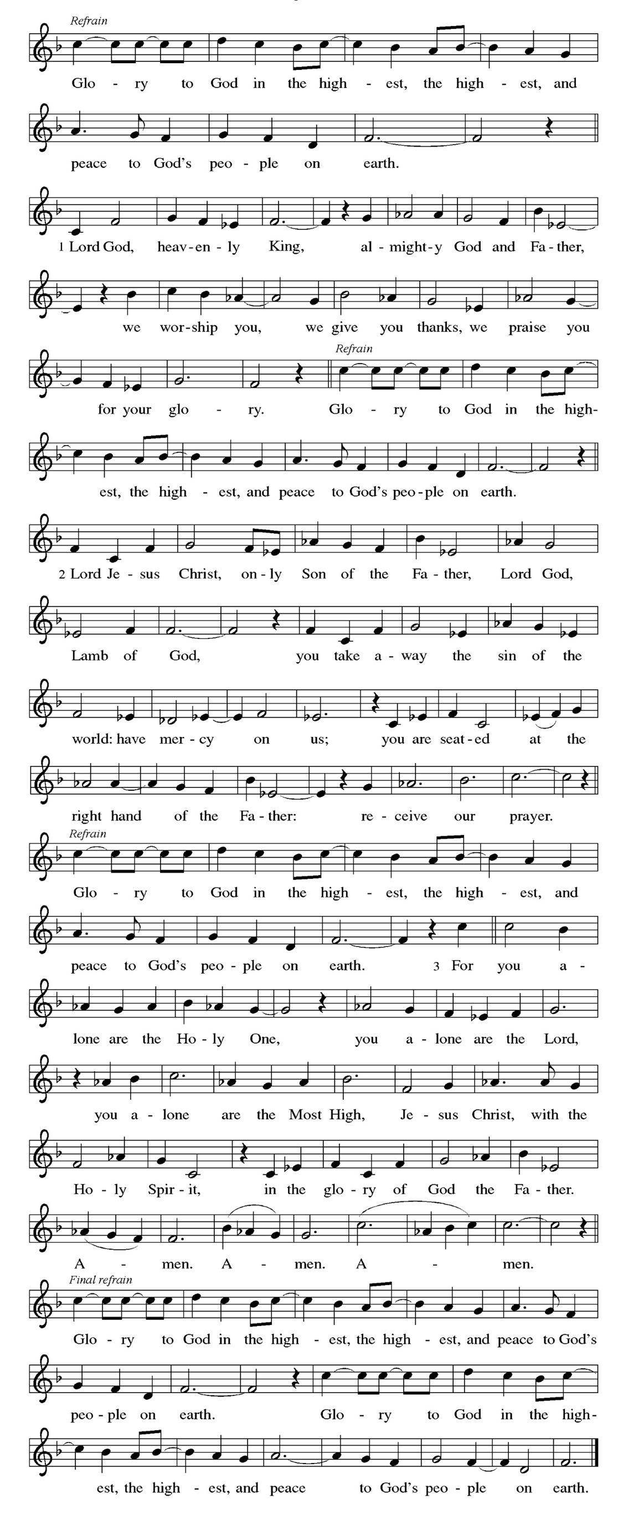

Prayer of the Day
P O Lord God, merciful judge, you are the inexhaustible fountain of forgiveness. Replace our hearts of stone with hearts that love and adore you, that we may delight in doing your will, through Jesus Christ, our Savior and Lord.
C Amen

Please be seated
WORD
God speaks to us in scripture readings, preaching and song.

First Reading Genesis 50:15-21
After Jacob’s death the brothers of Joseph begged for forgiveness for the crime they had done against him. You intended to do me harm, Joseph said, but God used this as an opportunity to do good and save many lives.
¹⁵ Realizing that their father was dead, Joseph’s brothers said, “What if Joseph still bears a grudge against us and pays us back in full for all the wrong that we did to him?” ¹⁶ So they approached Joseph, saying, “Your father gave this instruction before he died, ¹⁷ ‘Say to Joseph: I beg you, forgive the crime of your brothers and the wrong they did in harming you.’ Now therefore please forgive the crime of the servants of the God of your father.” Joseph wept when they spoke to him. ¹⁸ Then his brothers also wept, fell down before him, and said, “We are here as your slaves.” ¹⁹ But Joseph said to them, “Do not be afraid! Am I in the place of God? ²⁰ Even though you intended to do harm to me, God intended it for good, in order to preserve a numerous people, as he is doing today. ²¹ So have no fear; I myself will provide for you and your little ones.” In this way he reassured them, speaking kindly to them.

L Word of God, word of life.
C Thanks be to God.

Psalm 103: 1-13
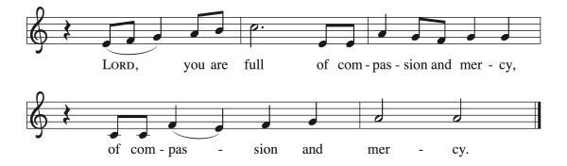
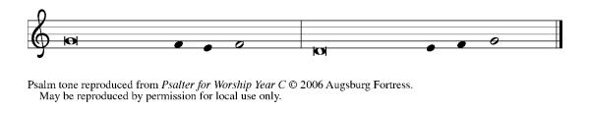
¹ Bless the Lord, | O my soul,
and all that is within me, bless God’s | holy name.
² Bless the Lord, | O my soul,
and forget not | all God’s benefits—
³ who forgives | all your sins
and heals all | your diseases;
⁴ who redeems your life | from the grave
and crowns you with steadfast | love and mercy; R
⁵ who satisfies your desires | with good things
so that your youth is renewed | like an eagle’s.
⁶ O Lord, you provide | vindication
and justice for all who | are oppressed.
⁷ You made known your | ways to Moses
and your works to the chil- | dren of Israel.
] ⁸ Lord, you are full of compas- | sion and mercy,
slow to anger and abounding in | steadfast love; R

⁹ you will not al- | ways accuse us,
nor will you keep your an- | ger forever.
¹⁰ You have not dealt with us according | to our sins,
nor repaid us according to | our iniquities.
¹¹ For as the heavens are high a- | bove the earth,
so great is your steadfast love for | those who fear you.
¹² As far as the east is | from the west,
so far have you removed our transgres- | sions from us.
¹³ As a father has compassion | for his children,
so you have compassion for those who fear | you, O Lord. R

Second Reading Romans 14:1-12

This Christian community has significant struggles with diversity. Here Paul helps us understand that despite different practices in worship and personal piety, we do not judge one another. All Christians belong to the Lord Jesus Christ who died for all of us and will judge each of us.

¹ Welcome those who are weak in faith but not for the purpose of quarreling over opinions. ² Some believe in eating anything, while the weak eat only vegetables. ³ Those who eat must not despise those who abstain, and those who abstain must not pass judgment on those who eat, for God has welcomed them. ⁴ Who are you to pass judgment on slaves of another? It is before their own lord that they stand or fall. And they will be upheld, for the Lord is able to make them stand.
⁵ Some judge one day to be better than another, while others judge all days to be alike. Let all be fully convinced in their own minds. ⁶ Those who observe the day, observe it for the Lord. Also, those who eat, eat for the Lord, since they give thanks to God, while those who abstain, abstain for the Lord and give thanks to God.
⁷ For we do not live to ourselves, and we do not die to ourselves. ⁸ If we live, we live to the Lord, and if we die, we die to the Lord; so then, whether we live or whether we die, we are the Lord’s. ⁹ For to this end Christ died and lived again, so that he might be Lord of both the dead and the living.

¹⁰ Why do you pass judgment on your brother or sister? Or you, why do you despise your brother or sister? For we will all stand before the judgment seat of God. ¹¹ For it is written,
“As I live, says the Lord, every knee shall bow to me,
and every tongue shall give praise to God.”
¹² So then, each one of us will be held accountable.

L Word of God, word of life.
C Thanks be to God.

Gospel Acclamation
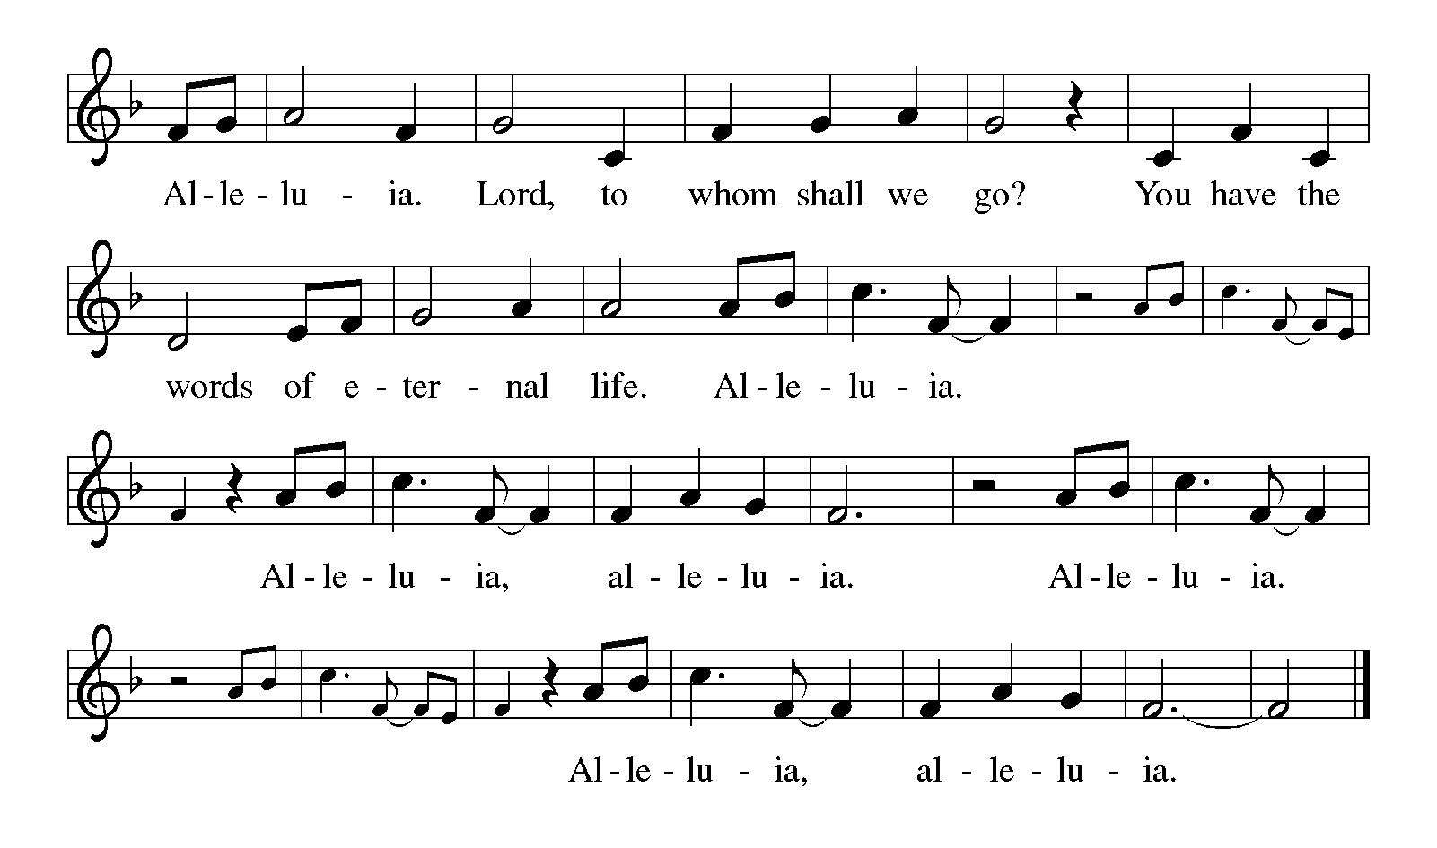

Gospel Matthew 18:21-35
P The holy gospel according to Matthew.
C Glory to you, O Lord.

When Peter asks about the limits of forgiveness, Jesus responds with a parable that suggests human forgiveness should mirror the unlimited mercy of God.
²¹ Peter came and said to [Jesus,] “Lord, if my brother or sister sins against me, how often should I forgive? As many as seven times?” ²² Jesus said to him, “Not seven times, but, I tell you, seventy-seven times.
²³ “For this reason the kingdom of heaven may be compared to a king who wished to settle accounts with his slaves. ²⁴ When he began the reckoning, one who owed him ten thousand talents was brought to him, ²⁵ and, as he could not pay, the lord ordered him to be sold, together with his wife and children and all his possessions and payment to be made. ²⁶ So the slave fell on his knees before him, saying, ‘Have patience with me, and I will pay you everything.’ ²⁷ And out of pity for him, the lord of that slave released him and forgave him the debt. ²⁸ But that same slave, as he went out, came upon one of his fellow slaves who owed him a hundred denarii, and seizing him by the throat he said, ‘Pay what you owe.’ ²⁹ Then his fellow slave fell down and pleaded with him, ‘Have patience with me, and I will pay you.’ ³⁰ But he refused; then he went and threw him into prison until he would pay the debt. ³¹ When his fellow slaves saw what had happened, they were greatly distressed, and they went and reported to their lord all that had taken place. ³² Then his lord summoned him and said to him, ‘You wicked slave! I forgave you all that debt because you pleaded with me. ³³ Should you not have had mercy on your fellow slave, as I had mercy on you?’ ³⁴ And in anger his lord handed him over to be tortured until he would pay his entire debt. ³⁵ So my heavenly Father will also do to every one of you, if you do not forgive your brother or sister from your heart.”

P The gospel of the Lord.
C Praise to you, O Christ.

Please be seated.
Children’s Message
Sermon
Please stand as you are able.

Hymn of the Day I Come With Joy ELW 482

Apostles’ Creed
I believe in God, the Father almighty, creator of heaven and earth.
I believe in Jesus Christ, God's only Son, our Lord, who was conceived by the Holy Spirit, born of the virgin Mary, suffered under Pontius Pilate, was crucified, died, and was buried; he descended to the dead. On the third day he rose again; he ascended into heaven, he is seated at the right hand of the Father, and he will come to judge the living and the dead.
I believe in the Holy Spirit, the holy catholic church, the communion of saints, the forgiveness of sins, the resurrection of the body, and life
everlasting. Amen

Prayers of Intercession
P Reminded of God’s gracious and abundant love, we offer our prayers, confident that God hears us.

A brief silence.

Move your church throughout the world away from judging and despising others. Lead us to embody the forgiveness you have given us in Jesus. Hear us, O God.
C your mercy is great.
P The endless beauty of your creation reminds us of your mercy. Protect those who care for farms and ranches. Guide those who lead us to wonder at your creation. Hear us, O God.
C your mercy is great.

P Raise up leaders (like John Chrysostom, Bishop of Constantinople, whom we remember today) to hold all in authority accountable for any misuse of the power entrusted to them. Hear us, O God.
C your mercy is great.

P Calm the fears of all in need with your promises. Compassionately free the lives of any who feel bound by their failures. Remember your children in need, especially those we name out loud or in our hearts:
Laurel Froelich, Dr. Ronald Gould, Chris Hunnicutt, Michael Jacques,
Sean Kelly, Devon Kirtley, Todd Kirtley, Tami Kuhlmann, George Lange,
Diane Malloy, Vangie McDorman, Craig Miller, Marge Pancher,
Frank Scott, Staci Thomas, Bob Titus, David Titus, Pearl Torrence, and Debbie Williams.
(The names on the prayer list are updated every 30 days. If you wish to continue to have someone on the list, please contact the office.)

Hear us, O God.
C your mercy is great.

P Ground this congregation in the welcome you show us in forgiving our sin. Inspire each of us to welcome others for your honor and glory. Hear us, O God.
C your mercy is great.

P With you is found the joy and promise of eternal life. Keep us in that joy as we remember all those who have gone before us. Hear us, O God.
C your mercy is great.

P Grant the prayers we have offered, what we have forgotten to ask, and whatever else you see that we need. We ask this in Jesus’ name.
C Amen

Peace

P The peace of Christ be with you always.
C And also with you.

The offering plate is located on the table as you enter/exit the worship space.

MEAL
God feeds us with the presence of Jesus Christ.

Offering Response God of All Creation Hal Hopson
Sanctuary Choir
Please stand.

Offering Prayer

P Let us pray,
God of creation, you send rain and the earth springs forth abundantly.
All blessings are from you; make us generous with what we have.
Use our gifts, our abilities, and our hearts in service to you and in love to our neighbors, today and always.
C Amen.

Dialogue
P The Lord be with you.
C And also with you.

P Lift up your hearts.
C We lift them to the Lord.

P Let us give thanks to the Lord our God.
C It is right to give our thanks and praise.

Preface
P It is indeed right, our duty and our joy, …
...we praise your name and join their unending hymn:

Holy, Holy,
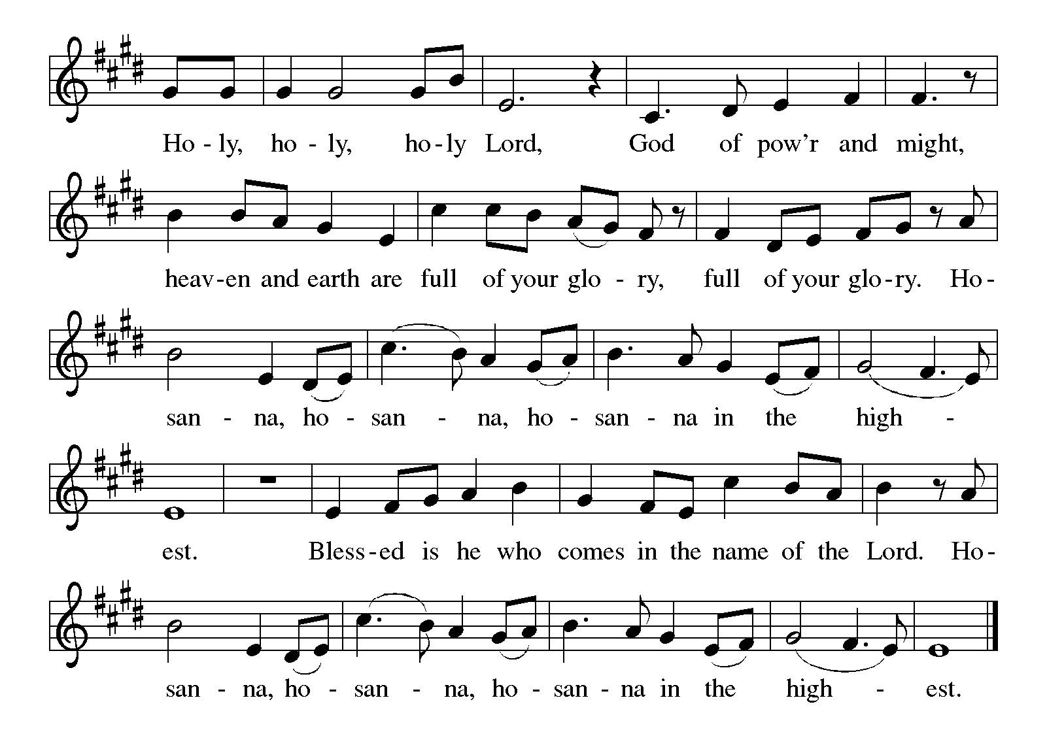

Eucharistic Prayer
P Holy, mighty, and merciful Lord, heaven and earth are full of your glory.
In great love you sent us to Jesus, you Son, who reached out to heal the sick and suffering, who preached good news to the poor, and who, on the cross, opened his arms to all.

In the night in which he was betrayed, our Lord Jesus took bread, gave thanks: broke it, and gave it to his disciples, saying: Take and eat; this is my body, given for you. Do this for the remembrance of me.

Again, after supper, he took the cup, gave thanks, and gave it for all to drink, saying: This cup is the new covenant in my blood shed for you and for all people for the forgiveness of sin. Do this for the remembrance of me.

Remembering, therefore, his death, resurrection, and ascension, we await his coming in glory.

Pour out upon us the Spirit of your love, O Lord, and unite the wills of all who share this heavenly food, the body and blood of Jesus Christ our Lord; to whom, with you and the Holy Spirit, be all glory and honor, now and forever.
C Amen

Lord's Prayer

C Our Father, who art in heaven, hallowed be thy name, thy kingdom come, thy will be done, on earth as it is in heaven. Give us this day our daily bread. and forgive us our trespasses, as we forgive those who trespass against us; and lead us not into temptation but deliver us from evil. For thine is the kingdom, and the power, and the glory, forever and ever. Amen.

Invitation to Communion
P Christ invites you to this table. All who are thirsty, all who are hungry, come!
This invitation is extended to all who receive Communion
in any Christian denomination. All are welcome!

Lamb of God
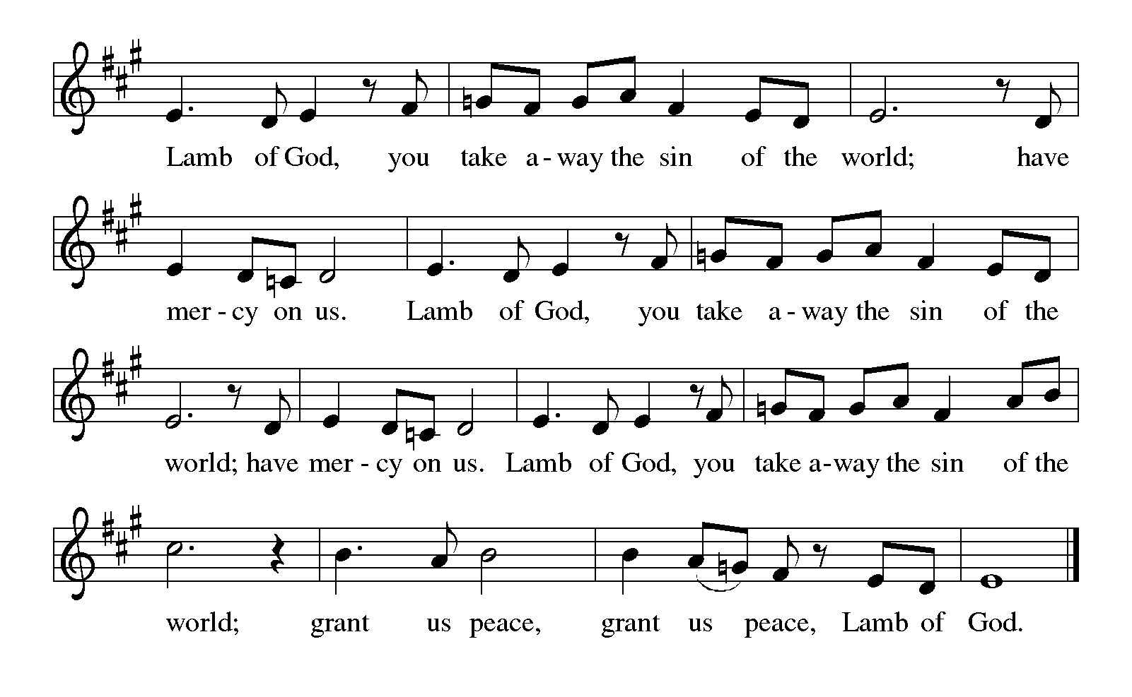

Communion

Communion Distribution Bread of Life From Heaven ELW 474

Anthem God Walks with Me Benjamin Kornellis
Communion Blessing

P The body and blood of our Lord Jesus Christ strengthen you and keep you in his grace.
C Amen.

Prayer after Communion

P Let us pray,
Sustaining God, with this bread and cup, you nourish us with mercy and abundant life. By your Spirit, send us from this table to serve a needy world. Make us living signs of your liberation, healing, and love,
following the way of Jesus, in whose name we pray.

C Amen.

SENDING
God blesses us and sends us in mission to the world.

Sending Song Joyful, Joyful We Adore Thee ELW 836

Blessing

P The God of love draw you into full accord and one mind,
in the body of Christ Jesus.
C Amen.
P The God of hope grant you strength and joy in all circumstances
through the interceding of the Spirit.
C Amen.

P The God of grace ☩ bless you now and forever.
C Amen.

Dismissal
P Go out in joy. Be led forth in peace.
C Thanks be to God.

Postlude

Weekly Readings Sept. 14 - 19

Mon 09/14 | Tues 09/15 | Wed 09/16 | Thurs 09/17 | Fri 09/18 | Sat 09/19
Psalm 133 | Psalm 133 | Psalm 133 | Psalm 145:  1-8 | Psalm 145:  1-8 | Psalm 145: 1-8
Genesis 48:  8-22 | Genesis 49:  29-50:14 | Genesis 50: 22-26 | Nahum 1:1,  14-2:2 | Nahum 2:  3-13 | Zephaniah 2:13-15
Hebrews 11: 23-29 | Romans 14: 13-15:2 | Mark 11:  20-25 | 2 Corinthians 13:1-42 | 2 Corinthians 13: 5-10 | Matthew 19:  23-30

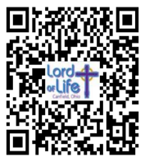
Scan for Online Giving Scan for September Calendar


Acknowledgements Copyright and streaming permission given through Sundaysandseasons.com under license #22472 for seasonal texts, prayers scripture readings, ELW Setting 8 (Glory to God, Gospel Acclamation, Holy, Holy, and Lamb of God), Psalm 103. ELW graphics.
ONELICENSE under #A-708717 for All Creatures, Worship God Most High Text © 1997 Augsburg Fortress; I Come With Joy Text © 1971, rev. 1995 Hope Publishing Co.; God of All Creation choral setting by Hal Hopson © 1978 GIA Publications ; Bread of Life From Heaven Text and music © 2001 GIA Publications; God Walks with Me choral setting by Benjamin Kornellis ©2025 Choristers Guild; Processional of Joy organ setting by Hal Hopson © 1987 Carl Fischer .
Public Domain: Joyful, Joyful, We Adore Thee.

This Week at Lord of Life

Sunday 10:15 a.m. Worship
6:00 p.m. Voices of Joy

Monday 6:30 p.m. Madrigal Group
7:00 p.m. Scouts
7:00 p.m. Cluster Meeting (at Zion)

Tuesday 10:30 a.m. Life Links
1:00 p.m. GriefShare
7:00 p.m. Scouts

Wednesday 10:30 a.m. Bible Study
5:00 p.m. Choir
7:00 p.m. Evening Prayer

Thursday 6:00 p.m. Church Council

Friday 10:00 a.m. Morning Prayer

Saturday 9am – 1pm Hall Rental
5:00 p.m. Saturday Worship

Serving in Worship in September

 | 09/06 | 09/13 | 09/20 | 09/30
Greeter/Usher | Jeff Dombroski | Phyllis Ruse | Gabe West | Zack West
Lector | Larry Cohol | Chris Eash | Judy McCartney | Pastor Mark Williams
Counters | Tom Drotleff | Tom Drotleff | Tom Drotleff | Tom Drotleff
Altar Guild | Diana Williams | Diana Williams | Norma Thomas | Norma Thomas
Crucifer
Acolyte

MORNING and EVENING PRAYERS RESUMING!

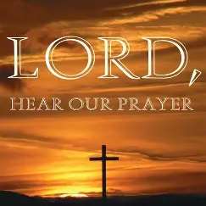
Evening Prayer will begin again on Wednesday, September 16th at 7:00 p.m. This simple service of prayer, readings and song will be broadcast live on our Facebook page each week.

Morning Prayer will begin again on Friday, September 18th at 10:00 a.m. Once again, this service will be broadcast live on our Facebook page.

We hope you can join us each week for these mid-week prayer events. You are also more than welcome to join us in person for these prayer opportunities as well.

CHILI COOK-OFF

Do you have a favorite Chili recipe?
Hot? Mild? Smoking Hot? Secret Ingredients? Have you always wanted to enter it in a chili cook-off? Here’s your chance—enter it in the Lord of Life Chili Cook-Off coming September 27th, 11:30am. Sign-up sheet in Narthex.

Wednesday Bible Study (10:30 am)


Sept 16th
Tom Drotleff will introduce the class to some on-line Bible study tools

Sept 23rd-Oct 21st
Pastor Becky will lead a study on the challenging parables of Jesus from Matthew’s Gospel that we will be hearing in worship during these fall months

Oct 28th-Dec 16th
Pastor Mark Williams closes out our liturgical Year of Matthew, with a study on the Sermon on the Mount.


Cluster-Wide study on “Faith and Civic Life”

While the exact dates/times are TBA, Pastor Becky will be leading a study on the social statement approved by the 2025 Church-wide Assembly called “Faith and Civic Life,” starting in mid-October. The study will be open to all Mahoning County Lutheran Cluster Churches. Keep an ear open for the time/date and an eye open for a sign-up sheet!

Cluster-wide Blessing of Animals
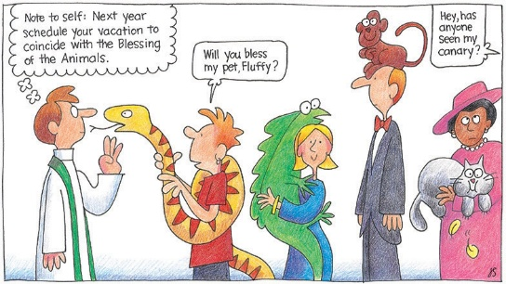
Prince of Peace Lutheran Church, Poland will hold a Blessing of Animals service on Sunday October 4th at 2 pm in their outdoor pavilion. Members and friends of all Mahoning County Lutheran Cluster churches are welcome.




Daniel and the Fiery Furnace

Saturday, Sept 19th
Online study started August 24th


GriefShare Grief Support Group
The next session of our GriefShare group will started Tuesday, September 15, at 1:00pm. There are thirteen sessions, and all are on Tuesdays, from 1:00pm to 2:30pm. Please register for the group at GriefShare.org.


For anyone interested in becoming a member or learning more about Lord of Life, we will hold a 2 session New Member class on Sunday October 4th and 11th after worship. These 2 classes will cover our basic beliefs as ELCA Lutherans, as well as more specific information about this congregation. Those who decide to join as members will be welcomed into membership


God Squad
(For our 8th Grade Confirmation Students)
Sept 27th Catch up and Check-in with your Sponsor at our Chili Cook-Off. Classes will resume October 18th!


Growing In Faith-NEOS
This is a learning opportunity offered by our synod in partnership with the Northwestern Ohio Synod. Participants gather in-person or on Zoom for six 5-week classes. Each class is 3 hours long and involves a combination of instruction, discussion and experiential learning. Begin with the “Foundations Year” classes, then decide if you would like to stretch yourself through a Practical Year. Each class is $65. Classes may be taken individually. Talk to Pastor Becky if financial assistance is needed: Otherwise, you can register at growinginfaithohio.org
Fall Classes:
Worship Matters: Sept 17, 24, Oct 1, 8
Christianity in a Lutheran Key: Oct 22, 29, Nov 5, 12, 19

THE GATHERING PLACE SENIOR CENTER EVENT

Monday, September 14th, 11:00am
Lord of Life Lutheran Church
550 North Broad St, Canfield, Oh 44406

Zack Felger, District Outreach & Education Specialist for Mahoning County Soil and Water, will present, “The Buzz of Overwintering - Protecting Pollinators.” He will address proper care for our gardens and flowers

