Lord of Life Lutheran Church

A Serving Community
God's work, our hands!
Rev. Rebecca Zielke, Pastor
Tim L. Elder, CAGO, Director of Music

17th Sunday after Pentecost
Sunday, September 20, 2026
10:15 a.m.


Matthew narrates one of Jesus’ controversial parables in which Jesus says that the reign of God is like that of a landowner who pays his workers the same wage no matter what time of day they began to work. When God changes God’s mind about punishing Nineveh for their evil ways, Jonah is angry. Yet God is gracious and merciful, abounding in steadfast love. In baptism we receive the grace of God that is freely given to all. As Martin Luther wrote, in the presence of God’s mercy we are all beggars.

550 North Broad Street 330-533-3531 Canfield, Ohio 44406 e-mail: lordoflife550@gmail.com

Welcome to Lord of Life!
Your presence in our midst is a blessing to us. We hope you find our worship service a prayerful and meaningful experience.

Visitors
If you are visiting with us this weekend, please consider signing our guest book located in our Gathering Space. An usher will be happy to assist you.

Holy Communion
All are welcome to partake in Communion regardless of Christian denomination. Please follow the usher’s direction to come forward to receive the bread from the Pastor and take a glass of wine from the tray. Dispose of the cup in the basket provided on the altar railing and return to your seat by the side aisle. Gluten free hosts are available upon request.

Worship notes
“ELW” refers to our hymnbook “Evangelical Lutheran Worship” which is the red hymnbook in the pew racks. Other hymns that may be included in our worship service, that do not appear in ELW, will be directly printed into the bulletin.

All items in bold print are responses spoken by the assembly.

Worship bulletin key: P = Pastor, L = Lector, C = Congregation.
Any other specific directions are notated in red throughout the bulletin.

The offering plate is located as you enter the worship space.

Restrooms
There are two sets of restrooms located in our building. The first, and closest, are found by exiting the sanctuary and turning to your right, down the hallway toward the coat room, and then turning right once again.
The second set, is located by exiting the sanctuary, turning right down the hallway toward the coat room and then turning left. Walk all the way down to the end of the hallway and they are located on your left.

GATHERING
The Holy Spirit calls us together as the people of God.
Announcements
Prelude Voluntary on the Hymn Tune ‘Slane’ Paul Manz
Please stand as you are able.
Confession and Forgiveness
All may make the sign of the cross, the sign that is marked at baptism, as the presiding minister begins.
P Blessed be the holy Trinity, ☩ one God,
who pours love into our hearts
and healing upon the earth.
C Amen.

Confident that God justifies us by grace through faith,
let us confess our sin.

Compassionate God,
C we confess that we struggle to embody your goodness
in the world and in our own hearts.
Creation groans from overuse.
Jealousy and bitterness strain our relationships.
Indifference keeps us from seeking justice.
Divisions disrupt your call to show genuine love
to others.
Turn our hearts back to you.
Restore our world and reconcile us to one another.
Renew us to live as your holy people,
following the way of Jesus Christ.
Amen.

P Hear this good news:
We have peace with God through ☩ Jesus Christ,
in whom there is no condemnation,
but only forgiveness and the promise of eternal life.
Receive freely this healing gift of grace.
C Amen.

Gathering Hymn Lord of Light ELW 688
Greeting
P The grace of our Lord Jesus Christ, the love of God and the communion of the Holy Spirit be with you all.
C And also with you.

Glory to God
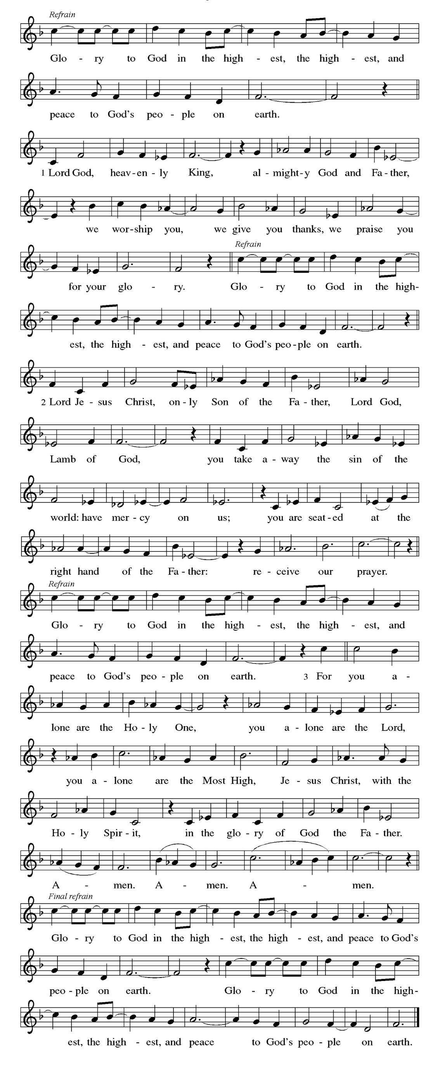

Prayer of the Day
P Almighty and eternal God, you show perpetual lovingkindness to us your servants. Because we cannot rely on our own abilities, grant us your merciful judgment, and train us to embody the generosity of your Son, Jesus Christ, our Savior and Lord.
C Amen

Please be seated
WORD
God speaks to us in scripture readings, preaching and song.

First Reading Jonah 3:10 – 4:11
After Jonah’s short sermon in 3:4, the Ninevites all repented and God decided to spare the city. Jonah objected to this and became even more angry when God ordered a worm to destroy a plant that was providing shade. The book ends with a question that challenges any who are not ready to forgive: You, Jonah, are all worked up about a bush, but shouldn’t I be concerned about a hundred and twenty thousand Ninevites?
¹⁰ When God saw what [the people of Ninevah] did, how they turned from their evil ways, God changed his mind about the calamity that he had said he would bring upon them, and he did not do it.
^{4:1} But this was very displeasing to Jonah, and he became angry. ² He prayed to the Lord and said, “O Lord! Is not this what I said while I was still in my own country? That is why I fled to Tarshish at the beginning, for I knew that you are a gracious and merciful God, slow to anger, abounding in steadfast love, and relenting from punishment. ³ And now, O Lord, please take my life from me, for it is better for me to die than to live.” ⁴ And the Lord said, “Is it right for you to be angry?” ⁵ Then Jonah went out of the city and sat down east of the city and made a booth for himself there. He sat under it in the shade, waiting to see what would become of the city.
⁶ The Lord God appointed a bush and made it come up over Jonah, to give shade over his head, to save him from his discomfort, so Jonah was very happy about the bush. ⁷ But when dawn came up the next day, God appointed a worm that attacked the bush, so that it withered. ⁸ When the sun rose, God prepared a sultry east wind, and the sun beat down on the head of Jonah so that he was faint and asked that he might die. He said, “It is better for me to die than to live.”
⁹ But God said to Jonah, “Is it right for you to be angry about the bush?” And he said, “Yes, angry enough to die.” ¹⁰ Then the Lord said, “You are concerned about the bush, for which you did not labor and which you did not grow; it came into being in a night and perished in a night. ¹¹ And should I not be concerned about Nineveh, that great city, in which there are more than a hundred and twenty thousand persons who do not know their right hand from their left and also many animals?”

L Word of God, word of life.
C Thanks be to God.

Psalm 145: 1-8
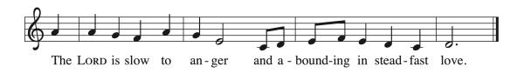
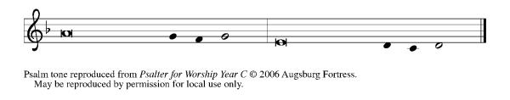

¹ I will exalt you, my | God and king,
and bless your name forev- | er and ever.
² Every day | will I bless you
and praise your name forev- | er and ever.
³ Great is the Lord and greatly | to be praised!
There is no end | to your greatness.
⁴ One generation shall praise your works | to another
and shall de- | clare your power. R
⁵ I will speak of the glorious splendor | of your majesty
and all your | marvelous works.
⁶ They shall tell of the might of your | wondrous acts,
and I will re- | count your greatness.
⁷ They shall publish the remembrance of | your great goodness;
they shall sing joyfully | of your righteousness.
⁸ The Lord is gracious and full | of compassion,
slow to anger and abounding in | steadfast love. R

Second Reading Philippians 1:21-30

Paul writes to the Philippians from prison. Though he is uncertain about the outcome of his imprisonment, he is committed to the ministry of the gospel and calls on the Philippians to live lives that reflect and enhance the gospel mission.
.
²¹ For to me, living is Christ and dying is gain. ²² If I am to live in the flesh, that means fruitful labor for me, yet I cannot say which I will choose. ²³ I am hard pressed between the two: my desire is to depart and be with Christ, for that is far better, ²⁴ but to remain in the flesh is more necessary for you. ²⁵ Since I am convinced of this, I know that I will remain and continue with all of you for your progress and joy in faith, ²⁶ so that, by my presence again with you, your boast might abound in Christ Jesus because of me.
²⁷ Only, live your life in a manner worthy of the gospel of Christ, so that, whether I come and see you or am absent and hear about you, I will know that you are standing firm in one spirit, striving side by side with one mind for the faith of the gospel ²⁸ and in no way frightened by those opposing you. For them, this is evidence of their destruction but of your salvation. And this is God’s doing. ²⁹ For he has graciously granted you the privilege not only of believing in Christ but of suffering for him as well, ³⁰ since you are having the same struggle that you saw I had and now hear that I still have.

L Word of God, word of life.
C Thanks be to God.

Please stand

Gospel Acclamation
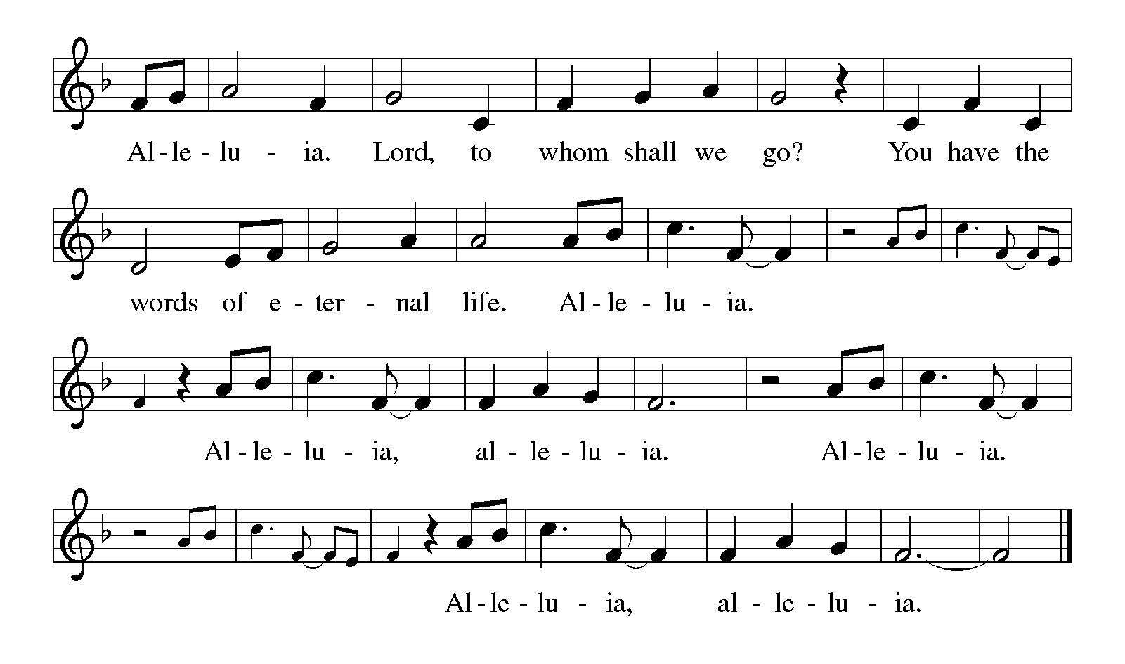

Gospel Matthew 20:1-16
P The holy gospel according to Matthew.
C Glory to you, O Lord.

Jesus tells a parable about God’s generosity, challenging the common assumption that God rewards people according to what they have earned or deserve.
[Jesus said to the disciples:] ¹ “The kingdom of heaven is like a landowner who went out early in the morning to hire laborers for his vineyard. ² After agreeing with the laborers for a denarius for the day, he sent them into his vineyard. ³ When he went out about nine o’clock, he saw others standing idle in the marketplace, ⁴ and he said to them, ‘You also go into the vineyard, and I will pay you whatever is right.’ So they went. ⁵ When he went out again about noon and about three o’clock, he did the same. ⁶ And about five o’clock he went out and found others standing around, and he said to them, ‘Why are you standing here idle all day?’ ⁷ They said to him, ‘Because no one has hired us.’ He said to them, ‘You also go into the vineyard.’ ⁸ When evening came, the owner of the vineyard said to his manager, ‘Call the laborers and give them their pay, beginning with the last and then going to the first.’ ⁹ When those hired about five o’clock came, each of them received a denarius. ¹⁰ Now when the first came, they thought they would receive more; but each of them also received a denarius. ¹¹ And when they received it, they grumbled against the landowner, ¹² saying, ‘These last worked only one hour, and you have made them equal to us who have borne the burden of the day and the scorching heat.’ ¹³ But he replied to one of them, ‘Friend, I am doing you no wrong; did you not agree with me for a denarius? ¹⁴ Take what belongs to you and go; I choose to give to this last the same as I give to you. ¹⁵ Am I not allowed to do what I choose with what belongs to me? Or are you envious because I am generous?’ ¹⁶ So the last will be first, and the first will be last.”
P The gospel of the Lord.
C Praise to you, O Christ.

Please be seated.
Children’s Message
Sermon
Please stand as you are able.
Hymn of the Day God’s Work, Our Hands ACS 1000
Please see the insert provided.

Apostles’ Creed
I believe in God, the Father almighty, creator of heaven and earth.
I believe in Jesus Christ, God's only Son, our Lord, who was conceived by the Holy Spirit, born of the virgin Mary, suffered under Pontius Pilate, was crucified, died, and was buried; he descended to the dead. On the third day he rose again; he ascended into heaven, he is seated at the right hand of the Father, and he will come to judge the living and the dead.
I believe in the Holy Spirit, the holy catholic church, the communion of saints, the forgiveness of sins, the resurrection of the body, and life
everlasting. Amen

Prayers of Intercession
P Reminded of God’s gracious and abundant love, we offer our prayers, confident that God hears us.

A brief silence.

Hold your church accountable for our unwillingness to share your good news and our anger at your generosity to others. Nourish us by your grace to be witnesses to your love. Hear us, O God.
C your mercy is great.
P Guide scientists and researchers studying responses to the climate crisis so that all your creation may inspire us to give thanks for your great goodness. Hear us, O God.
C your mercy is great.

P Show employers the benefits of equal pay standards for all their employees. Reconcile conflicts between employees. Fill places of employment with camaraderie and bring an end to employment disparity. Hear us, O God.
C your mercy is great.

P Encourage any who cannot work or who cannot work a full day with the truth that their value comes from your everlasting love for them. Provide for those who are injured, ill, and for all in any need, especially those we name out loud or in our hearts:
Laurel Froelich, Dr. Ronald Gould, Chris Hunnicutt, Michael Jacques,
Sean Kelly, Devon Kirtley, Todd Kirtley, Tami Kuhlmann, George Lange,
Diane Malloy, Vangie McDorman, Craig Miller, Marge Pancher,
Frank Scott, Staci Thomas, Bob Titus, David Titus, Pearl Torrence, and Debbie Williams.
(The names on the prayer list are updated every 30 days. If you wish to continue to have someone on the list, please contact the office.)

Hear us, O God.
C your mercy is great.

P Strengthen all those in this congregation whose labor serves the needs of others in the community. Inspire all in this congregation to support community endeavors with our time and talents. Hear us, O God.
C your mercy is great.

P Comfort us with the promise of the resurrection as we remember all our loved ones whose desire to be with Jesus is fulfilled. Hear us, O God.
C your mercy is great.

P Grant the prayers we have offered, what we have forgotten to ask, and whatever else you see that we need. We ask this in Jesus’ name.
C Amen

Peace

P The peace of Christ be with you always.
C And also with you.

Please be seated.

The offering plate is located on the table as you enter/exit the worship space.

MEAL
God feeds us with the presence of Jesus Christ.

Offering Response In the Singing ELW 466

Please stand.

Offering Prayer

P Let us pray,
God of creation, you send rain and the earth springs forth abundantly.
All blessings are from you; make us generous with what we have.
Use our gifts, our abilities, and our hearts in service to you and in love to our neighbors, today and always.
C Amen.

Dialogue
P The Lord be with you.
C And also with you.

P Lift up your hearts.
C We lift them to the Lord.

P Let us give thanks to the Lord our God.
C It is right to give our thanks and praise.

Preface
P It is indeed right, our duty and our joy, …
...we praise your name and join their unending hymn:

Holy, Holy,
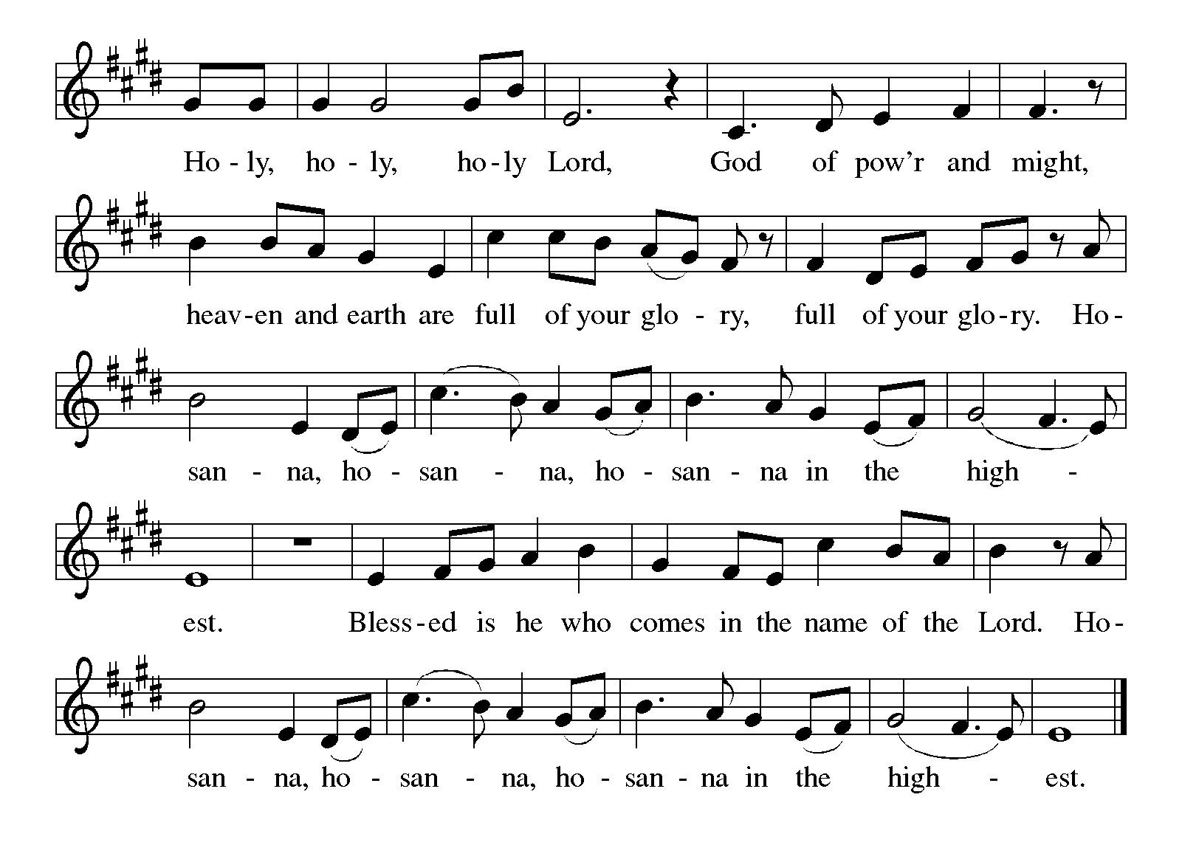

Eucharistic Prayer
P Holy, mighty, and merciful Lord, heaven and earth are full of your glory.
In great love you sent us to Jesus, your Son, who reached out to heal the sick and suffering, who preached good news to the poor, and who, on the cross, opened his arms to all.

In the night in which he was betrayed, our Lord Jesus took bread, gave thanks: broke it, and gave it to his disciples, saying: Take and eat; this is my body, given for you. Do this for the remembrance of me.

Again, after supper, he took the cup, gave thanks, and gave it for all to drink, saying: This cup is the new covenant in my blood shed for you and for all people for the forgiveness of sin. Do this for the remembrance of me.

Remembering, therefore, his death, resurrection, and ascension, we await his coming in glory.

Pour out upon us the Spirit of your love, O Lord, and unite the wills of all who share this heavenly food, the body and blood of Jesus Christ our Lord; to whom, with you and the Holy Spirit, be all glory and honor, now and forever.
C Amen

Lord's Prayer

C Our Father, who art in heaven, hallowed be thy name, thy kingdom come, thy will be done, on earth as it is in heaven. Give us this day our daily bread. and forgive us our trespasses, as we forgive those who trespass against us; and lead us not into temptation but deliver us from evil. For thine is the kingdom, and the power, and the glory, forever and ever. Amen.

Invitation to Communion
P Christ invites you to this table. All who are thirsty, all who are hungry, come!

Lamb of God
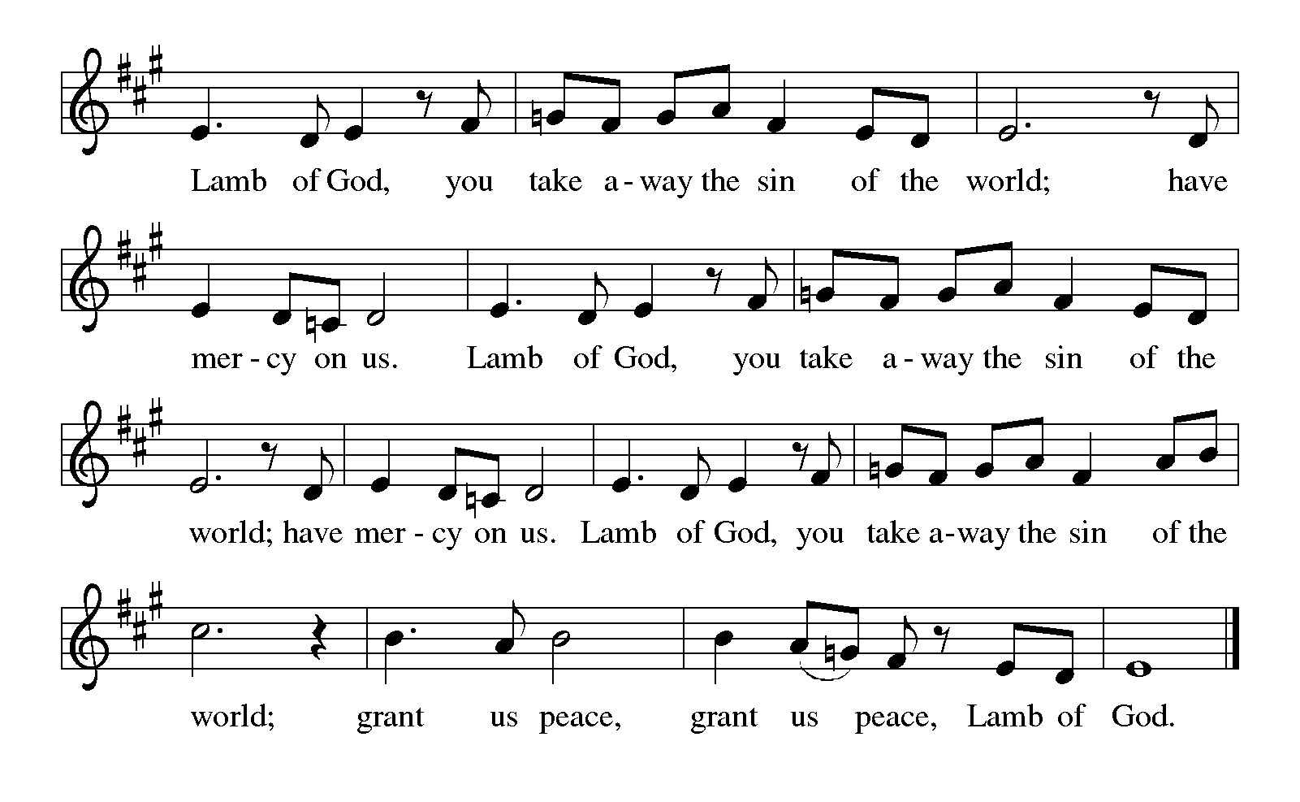

Please be seated
Communion

Communion Distribution Will You Let Me Be Your Servant ELW 659

Anthem Be Thou My Vision arr. Marie Pooler

Please stand

Communion Blessing

P The body and blood of our Lord Jesus Christ strengthen you and keep you in his grace.
C Amen.
Prayer after Communion

P Let us pray,
Sustaining God, with this bread and cup, you nourish us with mercy and abundant life. By your Spirit, send us from this table to serve a needy world. Make us living signs of your liberation, healing, and love,
following the way of Jesus, in whose name we pray.

C Amen.

SENDING
God blesses us and sends us in mission to the world.

Sending Song Lord of all Hopefulness ELW 765

Blessing

P The God of love draw you into full accord and one mind,
in the body of Christ Jesus.
C Amen.
P The God of hope grant you strength and joy in all circumstances
through the interceding of the Spirit.
C Amen.

P The God of grace ☩ bless you now and forever.
C Amen.

Dismissal
P Go out in joy. Be led forth in peace.
C Thanks be to God.

Please be seated. It is our tradition here at Lord of Life to be seated during the postlude. If it is your desire to leave, please do so quietly. Thank you.

Postlude Be Thou My Vision Sylvia Oines

Weekly Readings September 21 through September 26

Mon 09/21 | Tues 09/22 | Wed 09/23 | Thurs 09/24 | Fri 09/25 | Sat 09/26
Psalm106: 1-12 | Psalm 106:  1-12 | Psalm 106:  1-12 | Psalm 25: 1-9 | Psalm 25:  1-9 | Psalm 25:  1-9
Genesis 27:1-29 | Genesis 28:10-17 | Isaiah 41:  1-13 | Ezekiel 12:  17-28 | Ezekiel 18:  5-18 | Ezekiel 18:  19-24
Romans 16:1-16 | Romans 16: 17-20 | Matthew 18:  1-5 | James 4:  11-16 | Acts 13:  32-41 | Mark 11:  27-33


Scan for Online Giving Scan for September Calendar


Acknowledgements Copyright and streaming permission given through Sundaysandseasons.com under license #22472 for seasonal texts, prayers scripture readings, ELW Setting 8 (Glory to God, Gospel Acclamation, Holy, Holy, and Lamb of God), Psalm 145. ELW graphics.
ONELICENSE under #A-708717 for Voluntary on the Hymn Tune ‘Slane’ organ setting by Paul Manz © 1980 Concordia Publishing House; Lord of Light Text © Union of Welsh Independents, Music © 1942, rend. © 1970 Hope Publishing; God’s Work, Our Hands Text © 2019 Evangelical Lutheran Church in America, admin. Augsburg Fortress, Music: © 1968 Augsburg Publishing House, admin. Augsburg Fortress; In the Singing Text and music © 1996 Hope Publishing Co.; Will You Let Me Be Your Servant Text and music © 1977 Scripture In Song, admin. Integrity Music; Be Thou My Vision choral setting arr. by Marie Pooler © 1962 Augsburg Fortress; Lord of All Hopefulness Text © Oxford University Press; Be Thou My Vision piano setting by Sylvia Oines © 2011 Augsburg Fortress.
Public Domain: Joyful, Joyful, We Adore Thee
This Week at Lord of Life

Sunday 9:30 a.m. Kids Time
9:30 a.m. Coffee and Conversation
10:15 a.m. Worship
6:00 p.m. Voices of Joy

Monday 10:00 a.m. Between the Lines Book Club
6:30 p.m. Madrigal Group
7:00 p.m. Scouts

Tuesday 10:30 a.m. Life Links
1:00 p.m. GriefShare
7:00 p.m. Scouts

Wednesday SERVANT DEADLINE
10:30 a.m. Bible Study
5:00 p.m. Choir
7:00 p.m. Evening Prayer

Thursday 11:30 a.m. Quilting Group
3:00 p.m. Spaghetti Dinner Drive Thru

Friday 10:00 a.m. Morning Prayer

Saturday 9 a.m. – 1 p.m. Church Hall Rental
5:00 p.m. Saturday Worship

 | 09/06 | 09/13 | 09/20 | 09/30
Greeter/Usher | Jeff Dombroski | Phyllis Ruse | Gabe West | Zack West
Lector | Larry Cohol | Chris Eash | Judy McCartney | Pastor Mark Williams
Counters | Tom Drotleff | Tom Drotleff | Tom Drotleff | Tom Drotleff
Altar Guild | Diana Williams | Diana Williams | Norma Thomas | Norma Thomas
Crucifer
Acolyte


MORNING and EVENING PRAYERS
We hope you can join us each week for these mid-week prayer events. You are also more than welcome to join us in person for these prayer opportunities as well.

Evening Prayer continues on Wednesdays, at 7:00 p.m. This simple service of prayer, readings and song will be broadcast live on our Facebook page each week.

Morning Prayer continues on Fridays, at 10:00 a.m. Once again, this service will be broadcast live on our Facebook page.


CHILI COOK-OFF

Do you have a favorite Chili recipe? Hot? Mild? Smoking Hot? Secret Ingredients? Have you always wanted to enter it in a chili cook-off? Here’s your chance—enter it in the Lord of Life Chili Cook-Off coming September 27th, 11:30am. Sign-up sheet in Narthex.


Wednesday Bible Study (10:30 am)
Sept 23rd-Oct 21st

Pastor Becky will lead a study on the challenging parables of Jesus from Matthew’s Gospel that we will be hearing in worship during these fall months



Cluster-Wide study on “Faith and Civic Life”

While the exact dates/times are TBA, Pastor Becky will be leading a study on the social statement approved by the 2025 Church-wide Assembly called “Faith and Civic Life,” starting in mid-October. The study will be open to all Mahoning County Lutheran Cluster Churches. Keep an ear open for the time/date and an eye open for a sign-up sheet!
a

Cluster-wide Blessing of Animals
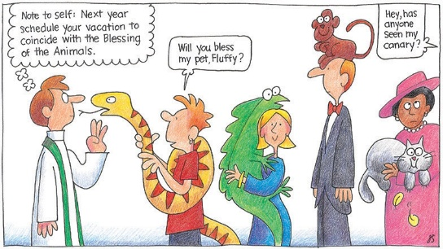
Prince of Peace Lutheran Church, Poland will hold a Blessing of Animals service on Sunday October 4th at 2 pm in their outdoor pavilion. Members and friends of all Mahoning County Lutheran Cluster churches are welcome.


GriefShare Grief Support Group
The next session of our GriefShare group will started Tuesday, September 15, at 1:00pm. There are thirteen sessions, and all are on Tuesdays, from 1:00pm to 2:30pm. Please register for the group at GriefShare.org.


NEW MEMBER CLASS
For anyone interested in becoming a member or learning more about Lord of Life, we will hold a 2 session New Member class on Sunday October 4th and 11th after worship. These 2 classes will cover our basic beliefs as ELCA Lutherans, as well as more specific information about this congregation. Those who decide to join as members will be welcomed into membership


ALTAR FLOWERS

The Altar Flowers this weekend are given to the Glory of God, and in memory of beloved sister, Margie, and for a Special Intention by
Norma Pignanelli,


GOD SQUAD
(For our 8th Grade Confirmation Students) Sept 27th Catch up and Check-in with your Sponsor at our Chili Cook-Off. Classes will resume October 18th!


“May the Lord watch between me and thee, while we are absent, one from the other.”


Best Spaghetti in Canfield!
MONTHLY DRIVE-THRU SPAGHETTI DINNER

Thursday, September 24th

3:00pm until 6:00pm, or until sold out!

Only $8.00 for a very generous amount of spaghetti and meat sauce, two slices freshly baked Italian bread with butter, tossed salad, and a brownie!

~~Notes~~

