Lord of Life Lutheran Church

A Serving Community
God's work, our hands!
Rev. Rebecca Zielke, Pastor
Tim L. Elder, CAGO, Director of Music

18th Sunday after Pentecost
Sunday, September 27, 2026
10:15 a.m.

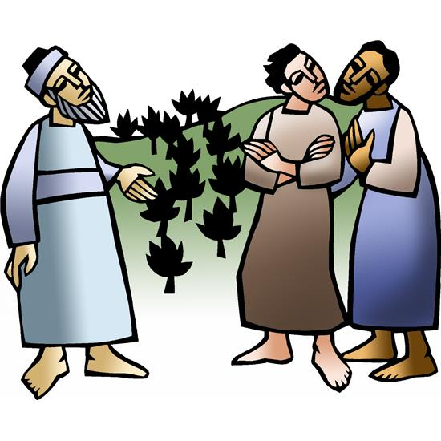

Jesus’ parable about two sons who don’t do what they say reveals surprises in the reign of God. In the reading from Ezekiel the people claim the ways of the Lord are unfair, while God offers repentance and new life. Paul urges us to look to Christ as a model of humility, putting the interests of others above our own. Nourished by the broken bread and shared cup, we offer our lives for the sake of our needy world.

550 North Broad Street 330-533-3531 Canfield, Ohio 44406 e-mail: lordoflife550@gmail.com

Welcome to Lord of Life!
Your presence in our midst is a blessing to us. We hope you find our worship service a prayerful and meaningful experience.

Visitors
If you are visiting with us this weekend, please consider signing our guest book located in our Gathering Space. An usher will be happy to assist you.

Holy Communion
All are welcome to partake in Communion regardless of Christian denomination. Please follow the usher’s direction to come forward to receive the bread from the Pastor and take a glass of wine from the tray. Dispose of the cup in the basket provided on the altar railing and return to your seat by the side aisle. Gluten free hosts are available upon request.

Worship notes
“ELW” refers to our hymnbook “Evangelical Lutheran Worship” which is the red hymnbook in the pew racks. Other hymns that may be included in our worship service, that do not appear in ELW, will be directly printed into the bulletin.

All items in bold print are responses spoken by the assembly.

Worship bulletin key: P = Pastor, L = Lector, C = Congregation.
Any other specific directions are notated in red throughout the bulletin.

The offering plate is located as you enter the worship space.

Restrooms
There are two sets of restrooms located in our building. The first, and closest, are found by exiting the sanctuary and turning to your right, down the hallway toward the coat room, and then turning right once again.
The second set, is located by exiting the sanctuary, turning right down the hallway toward the coat room and then turning left. Walk all the way down to the end of the hallway and they are located on your left.

GATHERING
The Holy Spirit calls us together as the people of God.
Announcements
Prelude Cornet Voluntary John Travers
Please stand as you are able.
Confession and Forgiveness
All may make the sign of the cross, the sign that is marked at baptism, as the presiding minister begins.
P Blessed be the holy Trinity, ☩ one God,
who pours love into our hearts
and healing upon the earth.
C Amen.

Confident that God justifies us by grace through faith,
let us confess our sin.

Compassionate God,
C we confess that we struggle to embody your goodness
in the world and in our own hearts.
Creation groans from overuse.
Jealousy and bitterness strain our relationships.
Indifference keeps us from seeking justice.
Divisions disrupt your call to show genuine love
to others.
Turn our hearts back to you.
Restore our world and reconcile us to one another.
Renew us to live as your holy people,
following the way of Jesus Christ.
Amen.

P Hear this good news:
We have peace with God through ☩ Jesus Christ,
in whom there is no condemnation,
but only forgiveness and the promise of eternal life.
Receive freely this healing gift of grace.
C Amen.

Gathering Hymn God Is Here ELW 526
Greeting
P The grace of our Lord Jesus Christ, the love of God and the communion of the Holy Spirit be with you all.

C And also with you.

Glory to God
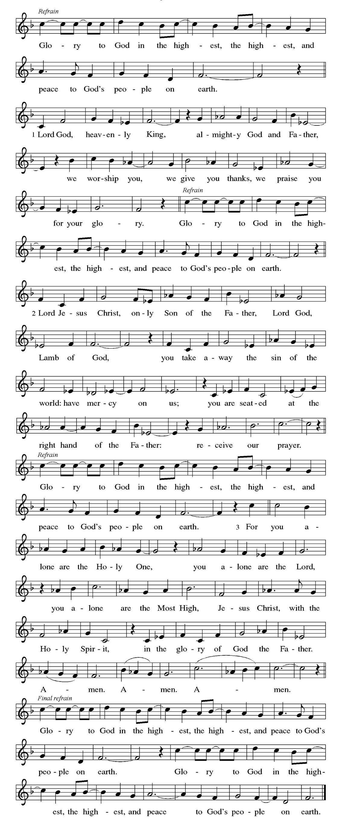

Prayer of the Day
P God of love, giver of life, you know our frailties and failings. Give us your grace to overcome them, keep us from those things that harm us, and guide us in the way of salvation, through Jesus Christ, our Savior and Lord.

C Amen

Please be seated
WORD
God speaks to us in scripture readings, preaching and song.

First Reading Ezekiel 18:1-4, 25-32
Ezekiel challenges those who think they cannot change because of what their parents were and did, or who think they cannot reverse their own previous behavior. God insistently invites people to turn and live.

¹ The word of the Lord came to me: ² What do you mean by repeating this proverb concerning the land of Israel, “The parents have eaten sour grapes, and the children’s teeth are set on edge”? ³ As I live, says the Lord God, this proverb shall no more be used by you in Israel. ⁴ Know that all lives are mine; the life of the parent as well as the life of the child is mine: it is only the person who sins who shall die.
²⁵ Yet you say, “The way of the Lord is unfair.” Hear now, O house of Israel: Is my way unfair? Is it not your ways that are unfair? ²⁶ When the righteous turn away from their righteousness and commit iniquity, they shall die for it; for the iniquity that they have committed, they shall die. ²⁷ Again, when the wicked turn away from the wickedness they have committed and do what is lawful and right, they shall save their life. ²⁸ Because they considered and turned away from all the transgressions that they had committed, they shall surely live; they shall not die. ²⁹ Yet the house of Israel says, “The way of the Lord is unfair.” O house of Israel, are my ways unfair? Is it not your ways that are unfair?
³⁰ Therefore I will judge you, O house of Israel, all of you according to your ways, says the Lord God. Repent and turn from all your transgressions; otherwise iniquity will be your ruin. ³¹ Cast away from you all the transgressions that you have committed against me, and get yourselves a new heart and a new spirit! Why will you die, O house of Israel? ³² For I have no pleasure in the death of anyone, says the Lord God. Turn, then, and live.

L Word of God, word of life.
C Thanks be to God.

Psalm 25: 1-9
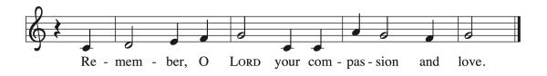
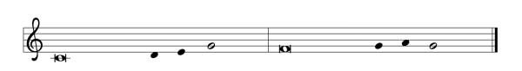
¹ To | you, O Lord,
I lift | up my soul.
² My God, I put my trust in you; let me not be | put to shame,
nor let my enemies triumph | over me.
³ Let none who look to you be | put to shame;
rather let those be put to shame | who are treacherous.
⁴ Show me your | ways, O Lord,
and teach | me your paths. R
⁵ Lead me in your | truth and teach me, for you are the God of my salvation; in you have I trusted all | the day long.
⁶ Remember, O Lord, your compassion and love,
for they are from | everlasting.

⁷ Remember not the sins of my youth and | my transgressions;
remember me according to your steadfast love and for the sake of your goodness, O Lord.
⁸ You are gracious and up- | right, O Lord;
therefore you teach sinners | in your way.
⁹ You lead the lowly in justice
and teach the lowly your way. R

Second Reading Philippians 2:1-13

As part of a call for harmony rather than self-seeking, Paul uses a very early Christian hymn that extols the selflessness of Christ in his obedient death on the cross. Christ’s selfless perspective is to be the essential perspective we share as the foundation for Christian accord.
.

¹ If, then, there is any comfort in Christ, any consolation from love, any partnership in the Spirit, any tender affection and sympathy, ² make my joy complete: be of the same mind, having the same love, being in full accord and of one mind. ³ Do nothing from selfish ambition or empty conceit, but in humility regard others as better than yourselves. ⁴ Let each of you look not to your own interests but to the interests of others. ⁵ Let the same mind be in you that was in Christ Jesus,
⁶ who, though he existed in the form of God,
did not regard equality with God
as something to be grasped,
⁷ but emptied himself,
taking the form of a slave,
assuming human likeness.
And being found in appearance as a human,
⁸ he humbled himself
and became obedient to the point of death—
even death on a cross.
⁹ Therefore God exalted him even more highly
and gave him the name
that is above every other name,
¹⁰ so that at the name given to Jesus
every knee should bend,
in heaven and on earth and under the earth,
¹¹ and every tongue should confess
that Jesus Christ is Lord,
to the glory of God the Father.
¹² Therefore, my beloved, just as you have always obeyed me, not only in my presence but much more now in my absence, work on your own salvation with fear and trembling, ¹³ for it is God who is at work in you, enabling you both to will and to work for his good pleasure.

L Word of God, word of life.
C Thanks be to God.

Please stand

Gospel Acclamation
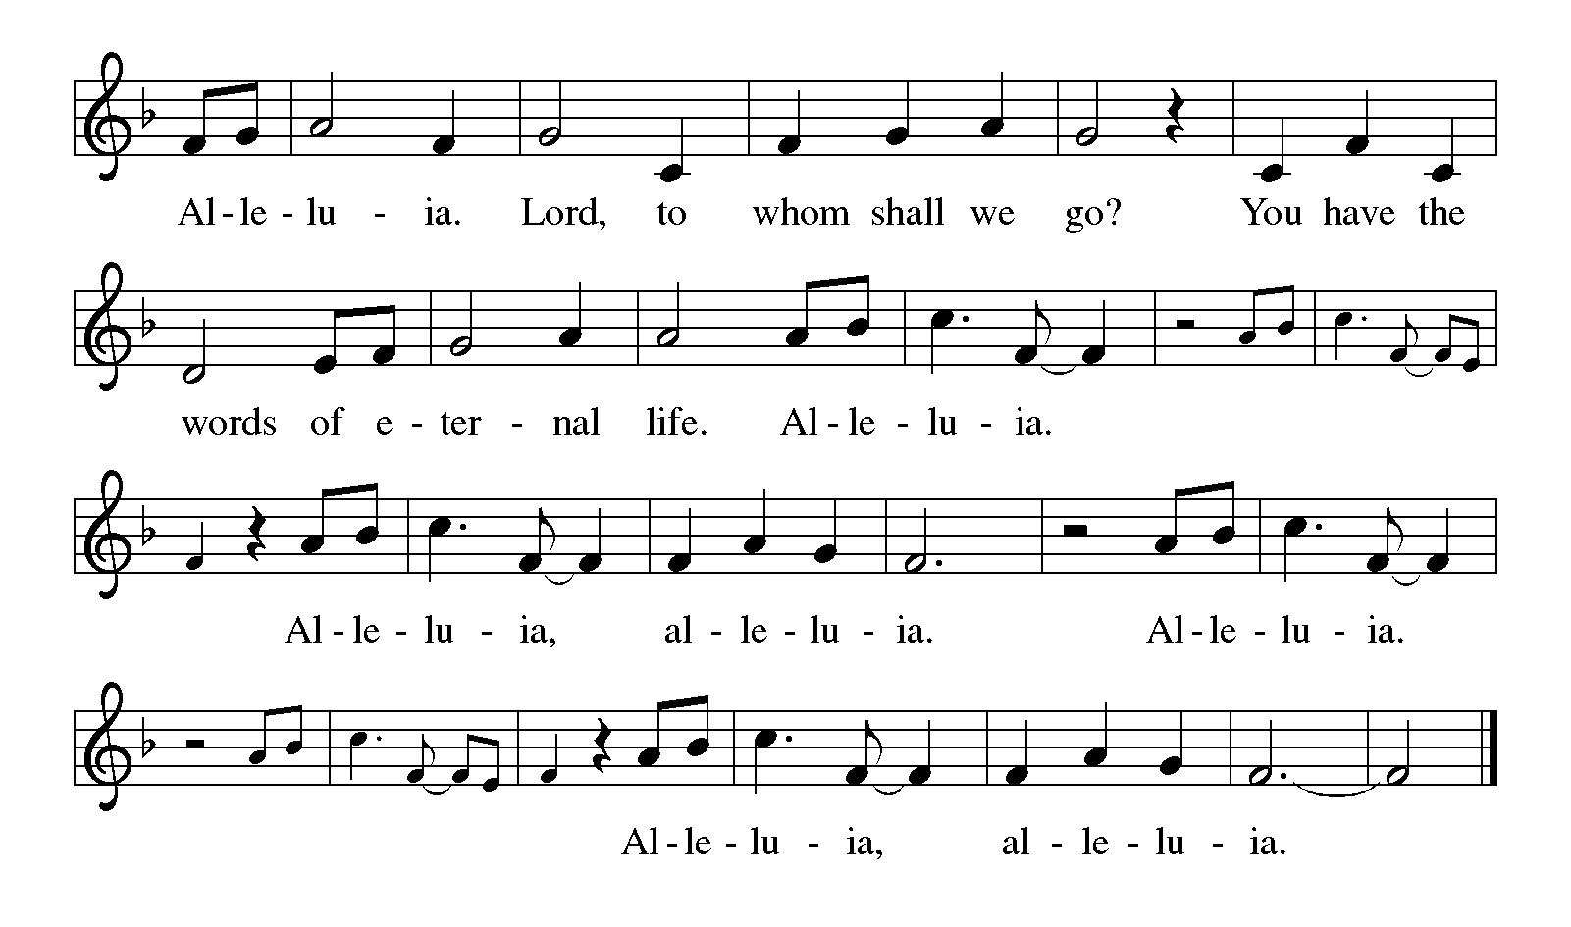

Gospel Matthew 21:23-32
After driving the moneychangers out of the temple (21:12), Jesus begins teaching there. His authority is questioned by the religious leaders, who are supposed to be in charge of the temple.

P The holy gospel according to Matthew.
C Glory to you, O Lord.

²³ When [Jesus] entered the temple, the chief priests and the elders of the people came to him as he was teaching and said, “By what authority are you doing these things, and who gave you this authority?” ²⁴ Jesus said to them, “I will also ask you one question; if you tell me the answer, then I will also tell you by what authority I do these things. ²⁵ Did the baptism of John come from heaven, or was it of human origin?” And they argued with one another, “If we say, ‘From heaven,’ he will say to us, ‘Why, then, did you not believe him?’ ²⁶ But if we say, ‘Of human origin,’ we are afraid of the crowd, for all regard John as a prophet.” ²⁷ So they answered Jesus, “We do not know.” And he said to them, “Neither will I tell you by what authority I am doing these things.
²⁸ “What do you think? A man had two sons; he went to the first and said, ‘Son, go and work in the vineyard today.’ ²⁹ He answered, ‘I will not,’ but later he changed his mind and went. ³⁰ The father went to the second and said the same, and he answered, ‘I go, sir,’ but he did not go. ³¹ Which of the two did the will of his father?” They said, “The first.” Jesus said to them, “Truly I tell you, the tax collectors and the prostitutes are going into the kingdom of God ahead of you. ³² For John came to you in the way of righteousness, and you did not believe him, but the tax collectors and the prostitutes believed him, and even after you saw it you did not change your minds and believe him.”
P The gospel of the Lord.
C Praise to you, O Christ.

Please be seated.
Children’s Message
Sermon
Please stand as you are able.
Hymn of the Day O Master, Let Me Walk With You ELW 818

Apostles’ Creed
I believe in God, the Father almighty, creator of heaven and earth. I believe in Jesus Christ, God's only Son, our Lord, who was conceived by the Holy Spirit, born of the virgin Mary, suffered under Pontius Pilate, was crucified, died, and was buried; he descended to the dead. On the third day he rose again; he ascended into heaven, he is seated at the right hand of the Father, and he will come to judge the living and the dead.
I believe in the Holy Spirit, the holy catholic church, the communion of saints, the forgiveness of sins, the resurrection of the body, and life everlasting. Amen

Prayers of Intercession
P Reminded of God’s gracious and abundant love, we offer our prayers, confident that God hears us.

A brief silence.

Center your church in humility as we strive to follow in your way. Help us listen to the cries of those who have been unfairly hurt by the church and dare to name difficult truths. Show all your love. Hear us, O God.

C your mercy is great.

P You call us to care for your creation. Lead us into your promise of a better world through sustainable practices and respect for your handiwork. Hear us, O God.
C your mercy is great.
P Inspire all in positions of authority to act honorably. Remind them of their call to use their authority for the sake of the common good. Give them the gift of humility. Hear us, O God.
C your mercy is great.

P Comfort those who come before you in fear and trembling. Calm troubled hearts with your forgiveness. Help all those in need especially those we name out loud or in our hearts…
Laurel Froelich, Dr. Ronald Gould, Chris Hunnicutt, Michael Jacques,
Sean Kelly, Devon Kirtley, Todd Kirtley, Tami Kuhlmann, George Lange,
Diane Malloy, Vangie McDorman, Craig Miller, Marge Pancher, Frank Scot,
Bob Titus, David Titus, Pearl Torrence, Debbie Williams, and the family of
Staci Thomas.
(The names on the prayer list are updated every 30 days. If you wish to continue to have someone on the list, please contact the office.)

Grant us your salvation. Hear us, O God.
C your mercy is great.

P Change this congregation’s heart when we say no to your call. Open us to courageous learning and service in our community, especially in new or challenging places. Hear us, O God.
C your mercy is great.

P Your steadfast love holds all the saints who have finished their work and are at rest. As we grieve, remind us of your mercy so we may also give thanks. Hear us, O God.
C your mercy is great.

P Grant the prayers we have offered, what we have forgotten to ask, and whatever else you see that we need. We ask this in Jesus’ name.
C Amen

Peace

P The peace of Christ be with you always.
C And also with you.

Please be seated.

The offering plate is located on the table as you enter/exit the worshipspace.

MEAL
God feeds us with the presence of Jesus Christ.

Offering Response In the Singing ELW 466

Please stand.

Offering Prayer

P Let us pray,
God of creation, you send rain and the earth springs forth abundantly. All blessings are from you; make us generous with what we have.Use our gifts, our abilities, and our hearts in service to you and in love to our neighbors, today and always.
C Amen.

Dialogue
P The Lord be with you.
C And also with you.

P Lift up your hearts.
C We lift them to the Lord.

P Let us give thanks to the Lord our God.
C It is right to give our thanks and praise.

Preface
P It is indeed right, our duty and our joy, …
...we praise your name and join their unending hymn:

Holy, Holy,
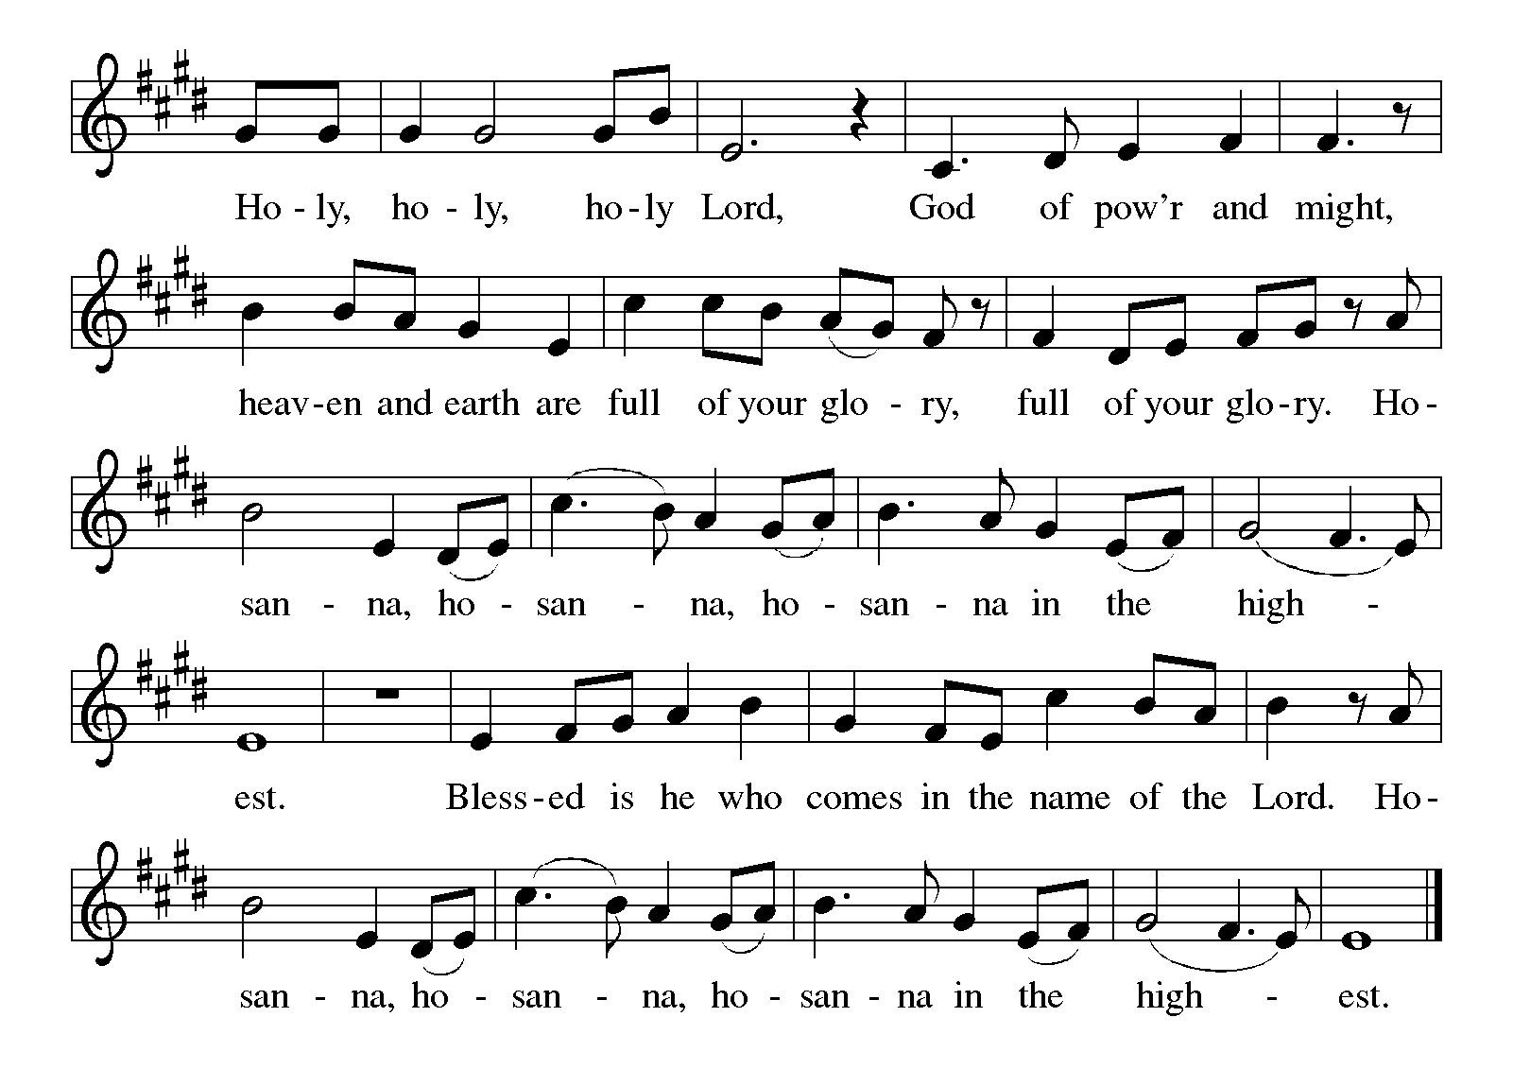

Eucharistic Prayer
P Holy, mighty, and merciful Lord, heaven and earth are full of your glory.
In great love you sent us to Jesus, your Son, who reached out to heal the sick and suffering, who preached good news to the poor, and who, on the cross, opened his arms to all.

In the night in which he was betrayed, our Lord Jesus took bread, gave thanks: broke it, and gave it to his disciples, saying: Take and eat; this is my body, given for you. Do this for the remembrance of me.

Again, after supper, he took the cup, gave thanks, and gave it for all to drink, saying: This cup is the new covenant in my blood shed for you and for all people for the forgiveness of sin. Do this for the remembrance of me.

Remembering, therefore, his death, resurrection, and ascension, we await his coming in glory.

Pour out upon us the Spirit of your love, O Lord, and unite the wills of all who share this heavenly food, the body and blood of Jesus Christ our Lord; to whom, with you and the Holy Spirit, be all glory and honor, now and forever.
C Amen

Lord's Prayer

C Our Father, who art in heaven, hallowed be thy name, thy kingdom come, thy will be done, on earth as it is in heaven. Give us this day our daily bread. and forgive us our trespasses, as we forgive those who trespass against us; and lead us not into temptation but deliver us from evil. For thine is the kingdom, and the power, and the glory, forever and ever. Amen.

Invitation to Communion
P Christ invites you to this table. All who are thirsty, all who are hungry, come!

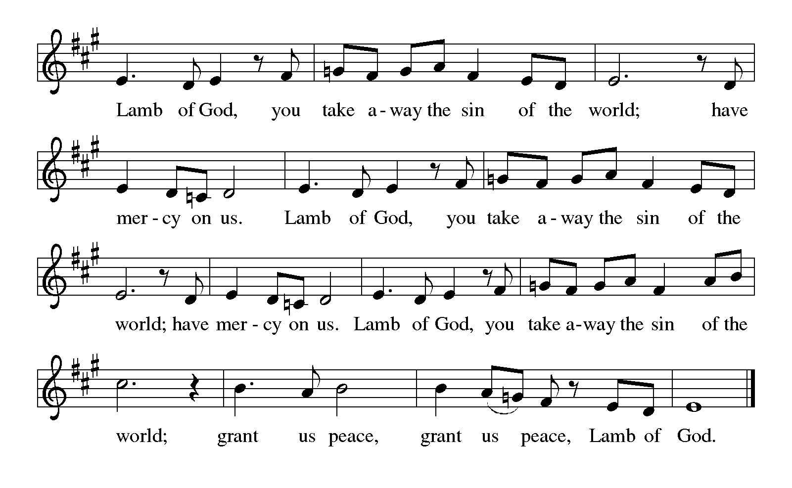
Lamb of God

Please be seated
Communion

Communion Distribution By Your Hand You Feed Your People ELW 469

Anthem Strengthen for Service Robert Hobby

Please stand

Communion Blessing

P The body and blood of our Lord Jesus Christ strengthen you and keep you in his grace.
C Amen.

Prayer after Communion

P Let us pray,
Sustaining God, with this bread and cup, you nourish us with mercy and abundant life. By your Spirit, send us from this table to serve a needy world. Make us living signs of your liberation, healing, and love, following the way of Jesus, in whose name we pray.

C Amen.
SENDING

God blesses us and sends us in mission to the world.

Sending Song Sent Forth By God’s Blessing ELW 547

Blessing

P The God of love draw you into full accord and one mind,
in the body of Christ Jesus.
C Amen.
P The God of hope grant you strength and joy in all circumstances
through the interceding of the Spirit.
C Amen.

P The God of grace ☩ bless you now and forever.
C Amen.

Dismissal
P Go out in joy. Be led forth in peace.
C Thanks be to God.

Please be seated. It is our tradition here at Lord of Life to be seated during the postlude. If it is your desire to leave, please do so quietly. Thank you.

Postlude Sent Forth By God’s Blessing (ELW 547) Charles Ore

Acknowledgements Copyright and streaming permission given through Sundaysandseasons.com under license #22472 for seasonal texts, prayers scripture readings, ELW Setting 8 (Glory to God, Gospel Acclamation, Holy, Holy, and Lamb of God), Psalm 25. ELW graphics.
ONELICENSE under #A-708717 for God Is Here! Text © 1979 Hope Publishing company, Music © 1942 ren. 1970 Hope Publishing; In the Singing Text and music © 1996 Hope Publishing Co.; By Your Hand, You Feed Your People Text and music © 2002 GIA Publications; Strengthen For Service choral setting by Robert Hobby © 2007 Augsburg Fortress; Sent Forth By God’s Blessing organ setting by Charles Ore © 1991 Concordia Publishing House.
Public Domain: O Master, Let Me Walk With Thee
This Week at Lord of Life

Sunday 9:30 a.m. Kids Time
9:30 a.m. Coffee and Conversation
10:15 a.m. Worship

Monday 6:30 p.m. Madrigal Group
7:00 p.m. Scouts

Tuesday 10:30 a.m. Life Links
1:00 p.m. GriefShare
7:00 p.m. Scouts

Wednesday 10:30 a.m. Bible Study
5:00 p.m. No Choir
7:00 p.m. No Evening Prayer

Thursday

Friday 10:00 a.m. No Morning Prayer

Saturday 5:00 p.m. Saturday Worship

Serving in Worship in September
 | 09/06 | 09/13 | 09/20 | 09/30
Greeter/Usher | Jeff Dombroski | Phyllis Ruse | Gabe West | Zack West
Lector | Larry Cohol | Chris Eash | Judy McCartney | Pastor Mark Williams
Counters | Tom Drotleff | Tom Drotleff | Tom Drotleff | Tom Drotleff
Altar Guild | Diana Williams | Diana Williams | Norma Thomas | Norma Thomas
Crucifer
Acolyte

Weekly Readings September 28 through October 03

Mon 09/28 | Tues 09/29 | Wed 09/30 | Thurs 10/01 | Fri 10/02 | Sat 10/03
Psalm 28 | Psalm 28 | Psalm 28 | Psalm 80:7-15 | Psalm 80:7-15 | Psalm 80:  7-15
Judges 16:1-22 | Judges 16:1-22 | Judges 16:23-31 | Jeremiah 2:  14-22 | Jeremiah 2:23-37 | Jeremiah 6:  1-10
Philippians 1:3-14 | Philippians 1:15-21 | Matthew 9:2-8 | Colossians 2:16-23 | Philippians 2:14-18, 31-4a | John 7:40-52

CHILI COOK-OFF

This is perfect chilly weather for chili! Look for a variety of kinds of chili at the Lord of Life Chili Cook-Off following Worship at 11:30am. Join us for fellowship, great food, and a fun time!

ALTAR FLOWERS

The Altar Flowers this weekend are given to the glory to God, in memory of Maria Ubelhart, and in honor of Hayley Reed’s birthday on September 25, by Traudi and Bryan Reed

Cluster-Wide study on “Faith and Civic Life”

Pastor Becky will be leading a study on the social statement approved by the 2025 Church-wide Assembly called “Faith and Civic Life,” on Monday, October 19, from 6:00-7:30pm in the Adult Sunday School room. The study will be open to all Mahoning County Lutheran Cluster Churches. Keep an eye (or two) open for a sign-up sheet!

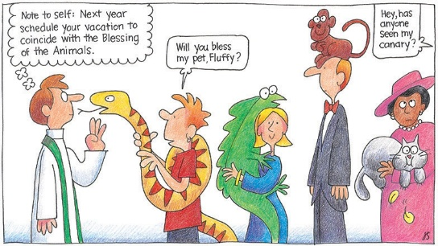
CLUSTER-WIDE BLESSING of ANIMALS
Prince of Peace Lutheran Church, Poland will hold a Blessing of Animals service on Sunday October 4th at 2 pm in their outdoor pavilion. Members and friends of all Mahoning County Lutheran Cluster churches are welcome.

Wednesday Bible Study (10:30 am)

Sept 23rd-Oct 21st
Pastor Becky will lead a study on the challenging parables of Jesus from Matthew’s Gospel that we will be hearing in worship during these fall months.

NEW MEMBER CLASS

For anyone interested in becoming a member or learning more about Lord of Life, we will hold a 2 session New Member class on Sunday October 4th and 11th after worship. These 2 classes will cover our basic beliefs as ELCA Lutherans, as well as more specific information about this congregation. Those who decide to join as members will be welcomed into membership


GOD SQUAD (For our 8th Grade Confirmation Students)Sept 27th Catch up and Check-in with your Sponsor at our Chili Cook-Off. Classes will resume October 18th!


There will be no choir practice or Wednesday evening prayer on Wednesday, September 30th, nor Friday morning prayer on Friday, October 2nd.


GriefShare Grief Support Group
The next session of our GriefShare group started Tuesday, September 15. There are thirteen sessions, and all are on Tuesdays, from 1:00pm to 2:30pm. Please register for the group at GriefShare.org.

~~NOTES~~

~~NOTES~~

