Lord of Life Lutheran Church

A Serving Community
God's work, our hands!
Rev. Rebecca Zielke, Pastor
Tim L. Elder, CAGO, Director of Music

All Saints
Sunday, November 1, 2026
10:15 a.m.

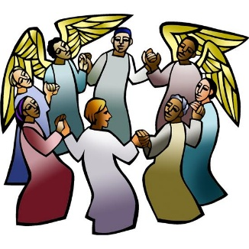

All Saints celebrates the baptized people of God, living and dead, who are the body of Christ. As November heralds the dying of the landscape in many northern regions, the readings and liturgy call us to remember all who have died in Christ and whose baptism is complete. At the Lord’s table we gather with the faithful of every time and place, trusting that the promises of God will be fulfilled and that all tears will be wiped away in the new Jerusalem.

550 North Broad Street 330-533-3531 Canfield, Ohio 44406 e-mail: lordoflife550@gmail.com

Welcome to Lord of Life!
Your presence in our midst is a blessing to us. We hope you find our worship service a prayerful and meaningful experience.

Visitors
If you are visiting with us this weekend, please consider signing our guest book located in our Gathering Space. An usher will be happy to assist you.

Holy Communion
All are welcome to partake in Communion regardless of Christian denomination. Please follow the usher’s direction to come forward to receive the bread from the Pastor and take a glass of wine from the tray. Dispose of the cup in the basket provided on the altar railing and return to your seat by the side aisle. Gluten free hosts are available upon request.

Worship notes
“ELW” refers to our hymnbook “Evangelical Lutheran Worship” which is the red hymnbook in the pew racks. Other hymns that may be included in our worship service, that do not appear in ELW, will be directly printed into the bulletin.

All items in bold print are responses spoken by the assembly.

Worship bulletin key: P = Pastor, L = Lector, C = Congregation.
Any other specific directions are notated in red throughout the bulletin.

The offering plate is located as you enter the worship space.

Restrooms
There are two sets of restrooms located in our building. The first, and closest, are found by exiting the sanctuary and turning to your right, down the hallway toward the coat room, and then turning right once again.
The second set, is located by exiting the sanctuary, turning right down the hallway toward the coat room and then turning left. Walk all the way down to the end of the hallway and they are located on your left

GATHERING
The Holy Spirit calls us together as the people of God.
Announcements
Prelude The Artist Joseph Martin
Eric and James McClellan and Janeen Williams-vocalists
Please stand as you are able.
Confession and Forgiveness
All may make the sign of the cross, the sign that is marked at baptism, as the presiding minister begins.
P Blessed be the holy Trinity, ☩ one God,
our dwelling place for all generations,
whose compassion never slumbers.
C Amen.

Let us confess our sin in the presence of God
and of one another.

Holy God,
C we confess that we have trusted in our preparation
instead of your invitation.
We prioritize our piety over care for your beloved.
We trust the voice of our shame and fear,
which keeps us from entering fully
into relationship with you and others.
We are not awake to the coming of your reign.
Rouse us and rescue us,
that we may enter into your joy.
Amen.

P Inherit the riches of God’s grace.
☩ Jesus, the good shepherd, feeds you with his mercy.
You are forgiven.
Blessed are you.
C Amen.

Gathering Hymn For All the Saints (verses 1 and 2) ELW 422
Greeting
P The grace of our Lord Jesus Christ, the love of God and the communion of the Holy Spirit be with you all.
C And also with you.

Glory to God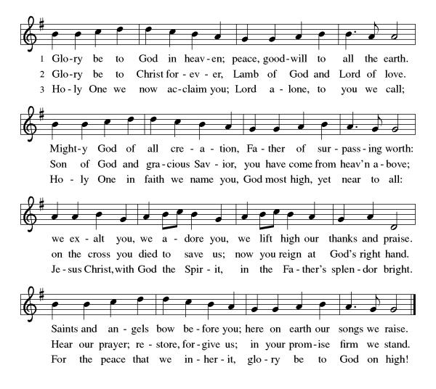

Prayer of the Day
P Let us pray,
Almighty God, you have knit your people together in one communion in the mystical body of your Son, Jesus Christ our Lord. Grant us grace to follow your blessed saints in lives of faith and commitment, and to know the inexpressible joys you have prepared for those who love you, through Jesus Christ, our Savior and Lord, who lives and reigns with you and the Holy Spirit, one God, now and forever.
C Amen

Please be seated
WORD
God speaks to us in scripture readings, preaching and song.

First Reading Revelation 7:9-17
The book of Revelation is written to seven churches in western Asia Minor during a time of great oppression. Today’s reading is a response to the question asked in 6:17: “Who is able to stand?” The writer gives the faithful the assurance of God’s protection and a vision of victory.

⁹ After this I looked, and there was a great multitude that no one could count, from every nation, from all tribes and peoples and languages, standing before the throne and before the Lamb, robed in white, with palm branches in their hands. ¹⁰ They cried out in a loud voice, saying,
“Salvation belongs to our God who is seated on the throne and to the Lamb!”
¹¹ And all the angels stood around the throne and around the elders and the four living creatures, and they fell on their faces before the throne and worshiped God, ¹² singing,

“Amen! Blessing and glory and wisdom
and thanksgiving and honor
and power and might
be to our God forever and ever! Amen.”
¹³ Then one of the elders addressed me, saying, “Who are these, robed in white, and where have they come from?” ¹⁴ I said to him, “Sir, you are the one who knows.” Then he said to me, “These are they who have come out of the great ordeal; they have washed their robes and made them white in the blood of the Lamb.
¹⁵ For this reason they are before the throne of God
and worship him day and night within his temple,
and the one who is seated on the throne will shelter them.
¹⁶ They will hunger no more and thirst no more;
the sun will not strike them,
nor any scorching heat,
¹⁷ for the Lamb at the center of the throne will be their shepherd,
and he will guide them to springs of the water of life,
and God will wipe away every tear from their eyes.”

L Word of God, word of life.
C Thanks be to God.

Psalm 34:1-10, 22
The psalm will be read responsively by whole verse.
¹ I will bless the Lord at all times;
the praise of God shall ever be in my mouth.
² I will glory in the Lord;
let the lowly hear and rejoice.
³ Proclaim with me the greatness of the Lord;
let us exalt God’s name together.
⁴ I sought the Lord, who answered me
and delivered me from all my terrors.
⁵ Look upon the Lord and be radiant,
and let not your faces be ashamed.
⁶ I called in my affliction, and the Lord heard me
and saved me from all my troubles.
⁷ The angel of the Lord encamps around those who fear the Lord
and delivers them.
⁸ Taste and see that the Lord is good;
happy are they who take refuge in God!
⁹ Fear the Lord, you saints of the Lord,
for those who fear the Lord lack nothing.
¹⁰ The lions are in want and suffer hunger,
but those who seek the Lord lack nothing that is good.
²² O Lord, you redeem the life of your servants,
and those who put their trust in you will not be punished.

Second Reading 1 John 3:1-3
A saint is one who has been set apart by God for God’s purposes. God, out of divine love, set us apart to be the children of God. Our holy hope is that we shall see God as God really is.
¹ See what love the Father has given us, that we should be called children of God, and that is what we are. The reason the world does not know us is that it did not know him. ² Beloved, we are God’s children now; what we will be has not yet been revealed. What we do know is this: when he is revealed, we will be like him, for we will see him as he is. ³ And all who have this hope in him purify themselves, just as he is pure.

L Word of God, word of life.
C Thanks be to God.

Please stand

Gospel Acclamation
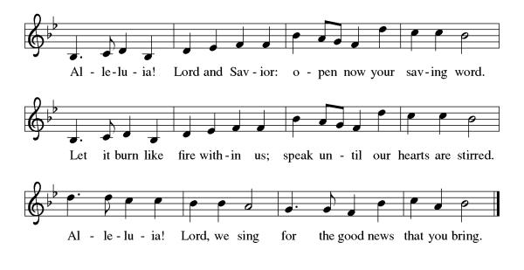

Gospel Matthew 5:1-12
In the Beatitudes, Jesus provides a unique description of those who are blessed with God’s favor. His teaching is surprising and shocking to those who seek wealth, fame, and control over others

P The holy gospel according to Matthew.
C Glory to you, O Lord.

¹ When Jesus saw the crowds, he went up the mountain, and after he sat down, his disciples came to him. ² And he began to speak and taught them, saying:
³ “Blessed are the poor in spirit, for theirs is the kingdom of heaven.
⁴ “Blessed are those who mourn, for they will be comforted.
⁵ “Blessed are the meek, for they will inherit the earth.
⁶ “Blessed are those who hunger and thirst for righteousness, for they will be filled.
⁷ “Blessed are the merciful, for they will receive mercy.
⁸ “Blessed are the pure in heart, for they will see God.
⁹ “Blessed are the peacemakers, for they will be called children of God.
¹⁰ “Blessed are those who are persecuted for the sake of righteousness, for theirs is the kingdom of heaven.
¹¹ “Blessed are you when people revile you and persecute you and utter all kinds of evil against you falsely on my account. ¹² Rejoice and be glad, for your reward is great in heaven, for in the same way they persecuted the prophets who were before you.”
P The gospel of the Lord.
C Praise to you, O Christ.

Please be seated.
Children’s Message
Sermon
Please stand as you are able.
Hymn of the Day Rejoice in God’s Saints ELW 418

Apostles’ Creed
I believe in God, the Father almighty, creator of heaven and earth.
I believe in Jesus Christ, God's only Son, our Lord, who was conceived by the Holy Spirit, born of the virgin Mary, suffered under Pontius Pilate, was crucified, died, and was buried; he descended to the dead. On the third day he rose again; he ascended into heaven, he is seated at the right hand of the Father, and he will come to judge the living and the dead.
I believe in the Holy Spirit, the holy catholic church, the communion of saints, the forgiveness of sins, the resurrection of the body, and life
everlasting. Amen

Prayers of Intercession
P United with the great cloud of witnesses, we offer our prayers for the church, the world, and all of creation.

A brief silence.

Fill your church with mercy and humility as we proclaim the gospel in our worship and witness in the world. Renew and inspire all who preach and teach among us. God, in your mercy,
C hear our prayer.

P Restore all lands suffering from ecological degradation. Protect soils and waterways (local places may be named). Point us toward innovative ways of living in harmony and joy with creation. God, in your mercy,
C hear our prayer.

P Unite the nations in their actions toward justice and peace. Raise up leaders who listen deeply for the needs of their communities, and surround the election process with wisdom and discernment. God, in your mercy,
C hear our prayer.

P Bring comfort and care to all who are in need, especially all who mourn this day. Sustain any who are weary, experiencing loneliness, or struggling with chronic illness especially those we name out loud or in our hearts.
Delores Bailey, Laurel Froelich, Dr. Ronald Gould, Chris Hunnicutt,
Michael Jacques, Sean Kelly, Daryl Kirtley, Devon Kirtley, Todd Kirtley, Tami Kuhlmann, George Lange, Joye Lange, Craig Miller, Marge Pancher, Frank Scott, Bob Titus, David Titus, Pearl Torrence, and Debbie Williams.
(The names on the prayer list are updated every 30 days. If you wish to continue to have someone on the list, please contact the office.)

God, in your mercy,
C hear our prayer.

P Nurture programs and communities that support elders and those who are homebound. Bless caregivers, nurses, chaplains, social workers, and hospice staff. Guide this congregation’s ministry with seniors and their families. God, in your mercy,
C hear our prayer.

P With grateful hearts we remember all who have died and now rest from their labors (those who have died in the past year may be named). Fill us with songs of praise until we too are gathered at your side. God, in your mercy,
C hear our prayer

P Into your steadfast love, faithful God, we entrust all for whom we pray, in the name of Jesus, your beloved.
C Amen

Peace

P The peace of Christ be with you always.
C And also with you.

Please be seated.
The offering plate is located on the table as you enter/exit the worship space.

MEAL
God feeds us with the presence of Jesus Christ.

Offering Response We Plow the Fields and Scatter ELW 681

Please stand.

Offering Prayer

P Let us pray,
Eternal God, our time, talents, and treasures are gifts from you.
Receive what we offer, and all that you entrust to us, until hungry no more, all the world is fed. through Jesus Christ, our Savior and Lord.
C Amen.

Dialogue
P The Lord be with you.
C And also with you.

P Lift up your hearts.
C We lift them to the Lord.

P Let us give thanks to the Lord our God.
C It is right to give our thanks and praise.

Preface
P It is indeed right, our duty and our joy, …
...we praise your name and join their unending hymn:

Holy, Holy,
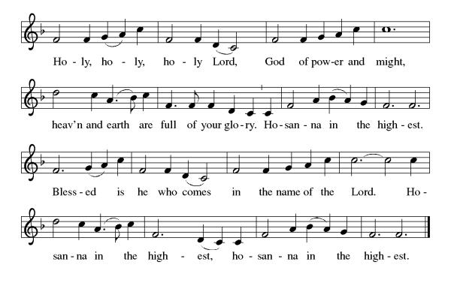
Eucharistic Prayer
P Holy, mighty, and merciful Lord, heaven and earth are full of your glory.
In great love you sent us to Jesus, your Son, who reached out to heal the sick and suffering, who preached good news to the poor, and who, on the cross, opened his arms to all.

In the night in which he was betrayed, our Lord Jesus took bread, gave thanks: broke it, and gave it to his disciples, saying: Take and eat; this is my body, given for you. Do this for the remembrance of me.

Again, after supper, he took the cup, gave thanks, and gave it for all to drink, saying: This cup is the new covenant in my blood shed for you and for all people for the forgiveness of sin. Do this for the remembrance of me.

Remembering, therefore, his death, resurrection, and ascension, we await his coming in glory.

Pour out upon us the Spirit of your love, O Lord, and unite the wills of all who share this heavenly food, the body and blood of Jesus Christ our Lord; to whom, with you and the Holy Spirit, be all honor and glory, now and forever.

C Amen

Lord's Prayer

C Our Father, who art in heaven, hallowed be thy name, thy kingdom come, thy will be done, on earth as it is in heaven. Give us this day our daily bread. and forgive us our trespasses, as we forgive those who trespass against us; and lead us not into temptation but deliver us from evil. For thine is the kingdom, and the power, and the glory, forever and ever. Amen.

Invitation to Communion
P In bread and cup the reign of Christ is breaking in.
Come, receive what Christ has prepared.

Lamb of God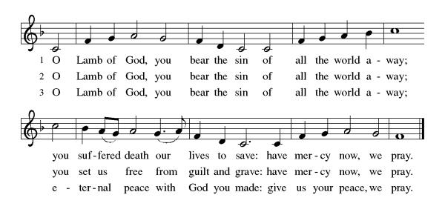

Please be seated
Communion
Communion Distribution
For All the Saints (verses 3-5) ELW 422 Shall We Gather At the River ELW 423

Anthem Well Done Faithful Servants Joseph Martin
Eric and James McClellan and Janeen Williams - vocalists

Please stand

Communion Blessing

P The body and blood of our Lord Jesus Christ strengthen you and keep you in his grace.
C Amen

Prayer after Communion

P Let us pray,
Holy God, we have received your never-ending mercy in this meal. You continuously seek the lost, bind the injured, and feed your people abundantly.
Now send us out, awake to your presence, now and forever.
C Amen.

SENDING
God blesses us and sends us in mission to the world.

Sending Song For All the Saints (verses 6 and 7) ELW 422

Blessing

P The holy Trinity,
Father, ☩ Son, and Holy Spirit, bless you with wisdom to welcome the reign of God, today and always.
C Amen.

Dismissal
P Go in peace. Encourage one another.
C Thanks be to God.

Please be seated. It is our tradition here at Lord of Life to be seated during the postlude. If it is your desire to leave, please do so quietly. Thank you.

Postlude In Paradisum Alfred Fedak
Acknowledgements Copyright and streaming permission given through Sundaysandseasons.com under license #22472 for seasonal texts, prayers scripture readings, ELW Setting 8 (Glory to God, Gospel Acclamation, Holy, Holy, and Lamb of God), Psalm 46. ELW graphics.
ONELICENSE under #A-708717 for The Artist choral setting by Joseph Martin © 1998 Shawnee Press; For All the Saints Music © Oxford University Press; Rejoice in God’s Saints Text © 1973 Hope Publishing Company; Well Done Faithful Servants choral setting by Joseph Martin © 1995 Shawnee Press; In Paradisum organ setting by Alfred Fedak © 1996 Selah Publications.
Public Domain: Shall We Gather at the River
 | 11/01 | 11/08 | 11/15 | 11/22 | 11/29
Greeter/Usher | Jeff Dombroski | Phyllis Ruse | Gabe West | Zack West | Bob Soles
Lector | Judy McCartney | Pastor Mark Williams | Norma Thomas | Diana Williams | Larry Cohol
Counters | Tom Drotleff | Tom Drotleff | Tom Drotleff | Tom Drotleff | Tom Drotleff
Altar Guild | Diana Williams | Diana Williams | Diana Williams | Norma Thomas | Norma Thomas
Crucifer
Weekly Readings November 02 through November 07

Acolyte
Those serving in Worship in November

Mon  11/02 | Tues  11/03 | Wed 11/04 | Thurs 11/05 | Fri 11/06 | Sat  11/07

Psalm 5 | Psalm 5 | Psalm 5 | Psalm 70 | Psalm 70 | Psalm 70
Jeremiah 5:18-31 | Lamentations 2:13-17 | Proverbs 16:21-33 | Amos 1:1-2:5 | Amos 3:1-12 | Amos 4:6-13
1Thessalonians 2:13-20 | Acts 13:1-12 | Matthew 15:1-9 | Revelation 8:6-9:12 | Revelation 9: 13-21 | Matthew 24:  1-14

Cluster-Wide study on “Faith and Civic Life”
Pastor Becky is leading a study on the social statement approved by the 2025 Church-wide Assembly called “Faith and Civic Life,” on six Mondays, 6:00-7:30pm, in the Adult Sunday School Room. The study is open to all Mahoning County Lutheran Cluster Churches.
*********************************************************

This Week at Lord of Life

Sunday 9:30 a.m. Kids Time
9:30 a.m. Coffee and Conversation
10:15 a.m. Worship

Monday 6:30 p.m. Madrigal Group
6:00 p.m. Social Statement Discussion
7:00 p.m. Scouts

Tuesday 10:30 a.m. Life Links
1:00 p.m. GriefShare
7:00 p.m. Scouts

Wednesday 10:30 a.m. Bible Study
5:00 p.m. Choir
7:00 p.m. Evening Prayer
Thursday

Friday 10:00 a.m. Morning Prayer

Saturday 5:00 p.m. Saturday Worship

****************************************************************
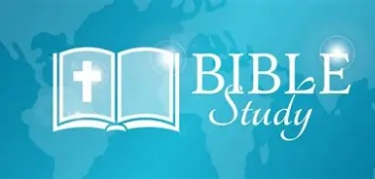
Wednesday Bible Study (10:30 am)

Pastor Mark Williams continues a study on the Sermon on the Mount. Please join us!
******************************************************************

Guest Musicians
We welcome Dan Laginya back to the organ bench this morning and thank him for sharing his talents with us! It is always a pleasure to have him fill in for our own director when he is away.
Thanks again, Dan!

We also wish to welcome our guest vocalists for this morning: Janeen Williams and her brothers Eric and James McClellan for sharing their gift of music with us. We thank you as well for sharing your talents with us this morning. Please welcome Dan, Janeen, Eric and James for their presence with us today.

*************************************************************************

COMMITMENT CARDS! If you did not receive a BRIGHT PINK financial commitment card in the mail recently, there are several in the Narthex. Please try to have all the cards returned by November 1st so work on the 2027 budget may begin. Thank you for your past and present financial support. You are appreciated


GriefShare Grief Support Group
Our GriefShare group started Tuesday, September 15. There are thirteen sessions, and all are on Tuesdays, from 1:00pm to 2:30pm. Please register for the group at GriefShare.org.

***********************************************************

WELCA - B I N G O!
For residents of Shepherd of the Valley - Boardman
Wednesday, November 4, 2:00pm
Please consider donating Bingo prizes for the winning residents – Dollar Tree, Dollar General, Family Dollar. Lists of prizes requested are available in the Narthex and will be in the November Servant.

Thank You!


ALTAR FLOWERS
The Altar Flowers this weekend are given to the Glory of God, and in memory of loved ones who have gone before us, given by Pastor Mark and Janeen Williams.

~~Notes~~

