Lord of Life Lutheran Church

A Serving Community
God's work, our hands!
Rev. Rebecca Zielke, Pastor
Tim L. Elder, CAGO, Director of Music

Reformation Sunday
Sunday, October 25, 2026
10:15 a.m.



Rooted in the past and growing into the future, the church must always be reformed in order to live out the love of Christ in an ever-changing world. We celebrate the good news of God’s grace, that Jesus Christ sets us free every day to do this life-transforming work. Trusting in the freedom given to us in baptism, we pray for the church, that Christians will unite more fully in worship and mission.

550 North Broad Street 330-533-3531 Canfield, Ohio 44406 e-mail: lordoflife550@gmail.com

Welcome to Lord of Life!
Your presence in our midst is a blessing to us. We hope you find our worship service a prayerful and meaningful experience.

Visitors
If you are visiting with us this weekend, please consider signing our guest book located in our Gathering Space. An usher will be happy to assist you.

Holy Communion
All are welcome to partake in Communion regardless of Christian denomination. Please follow the usher’s direction to come forward to receive the bread from the Pastor and take a glass of wine from the tray. Dispose of the cup in the basket provided on the altar railing and return to your seat by the side aisle. Gluten free hosts are available upon request.

Worship notes
“ELW” refers to our hymnbook “Evangelical Lutheran Worship” which is the red hymnbook in the pew racks. Other hymns that may be included in our worship service, that do not appear in ELW, will be directly printed into the bulletin.

All items in bold print are responses spoken by the assembly.

Worship bulletin key: P = Pastor, L = Lector, C = Congregation.
Any other specific directions are notated in red throughout the bulletin.

The offering plate is located as you enter the worship space.

Restrooms
There are two sets of restrooms located in our building. The first, and closest, are found by exiting the sanctuary and turning to your right, down the hallway toward the coat room, and then turning right once again.
The second set, is located by exiting the sanctuary, turning right down the hallway toward the coat room and then turning left. Walk all the way down to the end of the hallway and they are located on your left

GATHERING
The Holy Spirit calls us together as the people of God.
Announcements
Prelude A Mighty Fortress David Cherwien
Please stand as you are able.
Confession and Forgiveness
All may make the sign of the cross, the sign that is marked at baptism, as the presiding minister begins.
P Blessed be the holy Trinity, ☩ one God,
who pours love into our hearts
and healing upon the earth.
C Amen.

Confident that God justifies us by grace through faith,
let us confess our sin.

Compassionate God,
C we confess that we struggle to embody your goodness
in the world and in our own hearts.
Creation groans from overuse.
Jealousy and bitterness strain our relationships.
Indifference keeps us from seeking justice.
Divisions disrupt your call to show genuine love
to others.
Turn our hearts back to you.
Restore our world and reconcile us to one another.
Renew us to live as your holy people,
following the way of Jesus Christ.
Amen.

P Hear this good news:
We have peace with God through ☩ Jesus Christ,
in whom there is no condemnation,
but only forgiveness and the promise of eternal life.
Receive freely this healing gift of grace.
C Amen.

Gathering Hymn A Mighty Fortress Is Our God ELW 504
Greeting
P The grace of our Lord Jesus Christ, the love of God and the communion of the Holy Spirit be with you all.
C And also with you.

Glory to God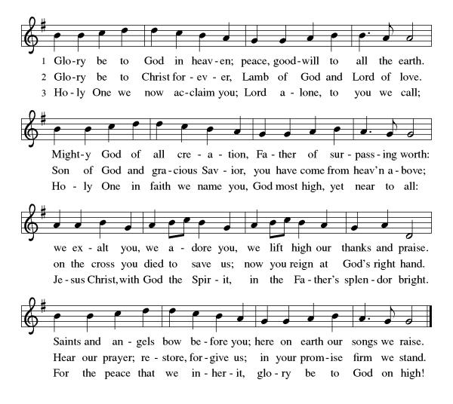
Prayer of the Day
P Let us pray,
Almighty God, gracious Lord, we thank you that your Holy Spirit renews the church in every age. Pour out your Holy Spirit on your faithful people. Keep them steadfast in your word, protect and comfort them in times of trial, defend them against all enemies of the gospel, and bestow on the church your saving peace, through Jesus Christ, our Savior and Lord, who lives and reigns with you and the Holy Spirit, one God, now and forever.
C Amen
Please be seated
WORD
God speaks to us in scripture readings, preaching and song.

First Reading Jeremiah 31:31-34
The renewed covenant will not be breakable, but like the old covenant it will expect the people to live upright lives. To know the Lord means that one will defend the cause of the poor and needy (Jer. 22:16). The renewed covenant is possible only because the Lord will forgive iniquity and not remember sin. Our hope lies in a God who forgets.
³¹ The days are surely coming, says the Lord, when I will make a new covenant with the house of Israel and the house of Judah. ³² It will not be like the covenant that I made with their ancestors when I took them by the hand to bring them out of the land of Egypt—a covenant that they broke, though I was their husband, says the Lord. ³³ But this is the covenant that I will make with the house of Israel after those days, says the Lord: I will put my law within them, and I will write it on their hearts, and I will be their God, and they shall be my people. ³⁴ No longer shall they teach one another or say to each other, “Know the Lord,” for they shall all know me, from the least of them to the greatest, says the Lord, for I will forgive their iniquity and remember their sin no more.

L Word of God, word of life.
C Thanks be to God.

Psalm 46
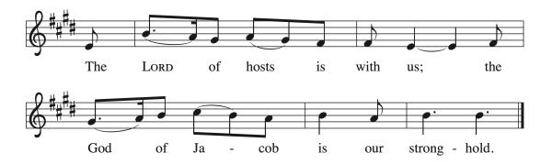

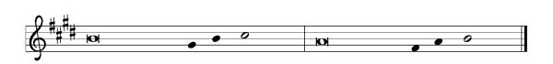

¹ God is our ref- | uge and strength,
a very present | help in trouble.
² Therefore we will not fear, though the | earth be moved,
and though the mountains shake in the depths | of the sea;
³ though its waters | rage and foam,
and though the mountains tremble | with its tumult.
⁴ There is a river whose streams make glad the cit- | y of God,
the holy habitation of | the Most High.
⁵ God is in the midst of the city; it shall | not be shaken;
God shall help it at the | break of day.
⁶ The nations rage, and the | kingdoms shake;
God speaks, and the earth | melts away. R
⁷ The Lord of | hosts is with us;
the God of Jacob | is our stronghold.
⁸ Come now, regard the works | of the Lord,
what desolations God has brought up- | on the earth;
⁹ behold the one who makes war to cease in | all the world;
who breaks the bow, and shatters the spear, and burns the | shields with fire.
¹⁰ “Be still, then, and know that | I am God;
I will be exalted among the nations; I will be exalted | in the earth.”
¹¹ The Lord of | hosts is with us;
the God of Jacob | is our stronghold. R

Second Reading Romans 3:19-28
Paul’s words stand at the heart of the preaching of Martin Luther and other Reformation leaders. No human beings make themselves right with God through works of the law. We are brought into a right relationship with God through the divine activity centered in Christ’s death. This act is a gift of grace that liberates us from sin and empowers our faith in Jesus Christ.
¹⁹ Now we know that, whatever the law says, it speaks to those who are under the law, so that every mouth may be silenced and the whole world may be held accountable to God. ²⁰ For no human will be justified before him by deeds prescribed by the law, for through the law comes the knowledge of sin.
²¹ But now, apart from the law, the righteousness of God has been disclosed and is attested by the Law and the Prophets, ²² the righteousness of God through the faith of Jesus Christ for all who believe. For there is no distinction, ²³ since all have sinned and fall short of the glory of God; ²⁴ they are now justified by his grace as a gift, through the redemption that is in Christ Jesus, ²⁵ whom God put forward as a sacrifice of atonement by his blood, effective through faith. He did this to demonstrate his righteousness, because in his divine forbearance he had passed over the sins previously committed; ²⁶ it was to demonstrate at the present time his own righteousness, so that he is righteous and he justifies the one who has the faith of Jesus.
²⁷ Then what becomes of boasting? It is excluded. Through what kind of law? That of works? No, rather through the law of faith. ²⁸ For we hold that a person is justified by faith apart from works prescribed by the law.

L Word of God, word of life.

C Thanks be to God.

Please stand

Gospel Acclamation
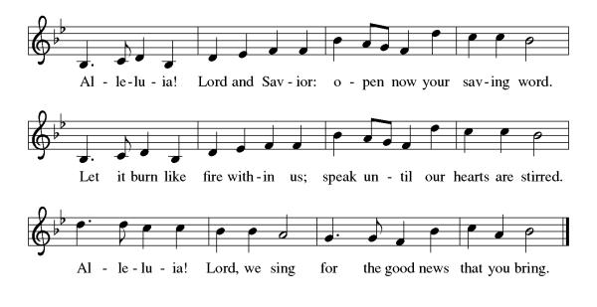

Gospel Matthew 22:34-46
Put on the spot by the Pharisees, Jesus displays wisdom by summarizing the law of God in just two commandments and by demonstrating the Messiah must be more than the son of David.

P The holy gospel according to Matthew.
C Glory to you, O Lord.

³⁴ When the Pharisees heard that [Jesus] had silenced the Sadducees, they gathered together, ³⁵ and one of them, an expert in the law, asked him a question to test him. ³⁶ “Teacher, which commandment in the law is the greatest?” ³⁷ He said to him, “ ‘You shall love the Lord your God with all your heart and with all your soul and with all your mind.’ ³⁸ This is the greatest and first commandment. ³⁹ And a second is like it: ‘You shall love your neighbor as yourself.’ ⁴⁰ On these two commandments hang all the Law and the Prophets.”
⁴¹ Now while the Pharisees were gathered together, Jesus asked them this question: ⁴² “What do you think of the Messiah? Whose son is he?” They said to him, “The son of David.” ⁴³ He said to them, “How is it then that David by the Spirit calls him Lord, saying,
⁴⁴ ‘The Lord said to my Lord,
“Sit at my right hand,
until I put your enemies under your feet” ’?
⁴⁵ “If David thus calls him Lord, how can he be his son?” ⁴⁶ No one was able to give him an answer, nor from that day did anyone dare to ask him any more questions.
P The gospel of the Lord.
C Praise to you, O Christ.

Please be seated.
Children’s Message
Sermon
Please stand as you are able.
Hymn of the Day Lord, Keep us Steadfast in Your Word ELW 517

Apostles’ Creed
I believe in God, the Father almighty, creator of heaven and earth.
I believe in Jesus Christ, God's only Son, our Lord, who was conceived by the Holy Spirit, born of the virgin Mary, suffered under Pontius Pilate, was crucified, died, and was buried; he descended to the dead. On the third day he rose again; he ascended into heaven, he is seated at the right hand of the Father, and he will come to judge the living and the dead.
I believe in the Holy Spirit, the holy catholic church, the communion of saints, the forgiveness of sins, the resurrection of the body, and life
everlasting. Amen

Prayers of Intercession
P Seeking the Spirit of God who makes all things new, we pray for the church and the world

A brief silence.

As we celebrate Reformation Sunday, we remember the witness of Martin Luther and the reformers of the church in every generation. Empower us to continue the work of reform and renewal in our own day. Hear us, O God.
C your mercy is great.

P We pray for the healing of natural places despoiled by pollution and human greed. Give all living creatures access to safe land, water, and air. Hear us, O God.
C your mercy is great.

P We pray for our criminal justice systems and all those whose lives are affected by them. Give wisdom and discernment to police, probation officers, judges, and attorneys; give courage and peace to prisoners and the formerly incarcerated. Hear us, O God.
C your mercy is great.

P We ask your blessing upon all people who have been harmed by the church and its leaders, that the truth may make them free. We pray for the relief of all those who are sick or suffering especially those we name before you now...
Delores Bailey, Laurel Froelich, Dr. Ronald Gould, Chris Hunnicutt,
Michael Jacques, Sean Kelly, Daryl Kirtley, Devon Kirtley, Todd Kirtley, Tami Kuhlmann, George Lange, Joy Lange, Craig Miller, Marge Pancher, Frank Scott, Bob Titus, David Titus, Pearl Torrence, and Debbie Williams.
(The names on the prayer list are updated every 30 days. If you wish to continue to have someone on the list, please contact the office.)

Hear us, O God.
C your mercy is great.

P We give thanks for those exploring or returning to a life of faith. Encourage and guide them, that they may find their hope in you. Hear us, O God.
C your mercy is great.

P With gratitude, we remember those disciples who paved the way for us and all of our beloved dead. Hear us, O God.
C your mercy is great.

P Trusting in your boundless grace, O God, we lift up these spoken prayers and those in our hearts; through Jesus Christ our Lord.
C Amen

Peace

P The peace of Christ be with you always.
C And also with you.

Please be seated.
The offering plate is located on the table as you enter/exit the worship space.

MEAL
God feeds us with the presence of Jesus Christ.

Offering Response In the Singing ELW 466

Please stand.

Offering Prayer

P Let us pray,
God of creation, you send rain and the earth springs forth abundantly.
All blessings are from you; make us generous with what we have.
Use our gifts, our abilities, and our hearts in service to you and in love to our neighbors, today and always.
C Amen.

Dialogue
P The Lord be with you.
C And also with you.

P Lift up your hearts.
C We lift them to the Lord.

P Let us give thanks to the Lord our God.
C It is right to give our thanks and praise.

Preface
P It is indeed right, our duty and our joy, …
...we praise your name and join their unending hymn:

Holy, Holy,
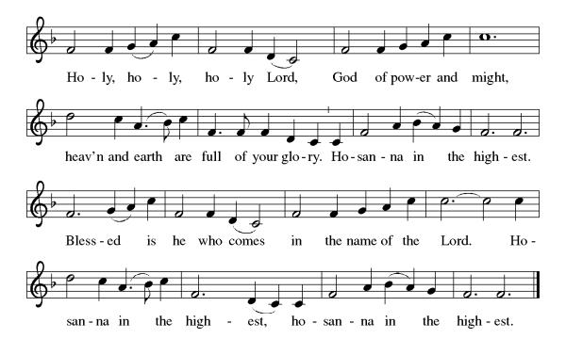
Eucharistic Prayer
P Holy, mighty, and merciful Lord, heaven and earth are full of your glory.
In great love you sent us to Jesus, your Son, who reached out to heal the sick and suffering, who preached good news to the poor, and who, on the cross, opened his arms to all.

In the night in which he was betrayed, our Lord Jesus took bread, gave thanks: broke it, and gave it to his disciples, saying: Take and eat; this is my body, given for you. Do this for the remembrance of me.

Again, after supper, he took the cup, gave thanks, and gave it for all to drink, saying: This cup is the new covenant in my blood shed for you and for all people for the forgiveness of sin. Do this for the remembrance of me.

Remembering, therefore, his death, resurrection, and ascension, we await his coming in glory.

Pour out upon us the Spirit of your love, O Lord, and unite the wills of all who share this heavenly food, the body and blood of Jesus Christ our Lord; to whom, with you and the Holy Spirit, be all honor and glory, now and forever.

C Amen

Lord's Prayer

C Our Father, who art in heaven, hallowed be thy name, thy kingdom come, thy will be done, on earth as it is in heaven. Give us this day our daily bread. and forgive us our trespasses, as we forgive those who trespass against us; and lead us not into temptation but deliver us from evil. For thine is the kingdom, and the power, and the glory, forever and ever. Amen.

Invitation to Communion
P Christ invites you to this table. All who are thirsty, all who are hungry, come!
Lamb of God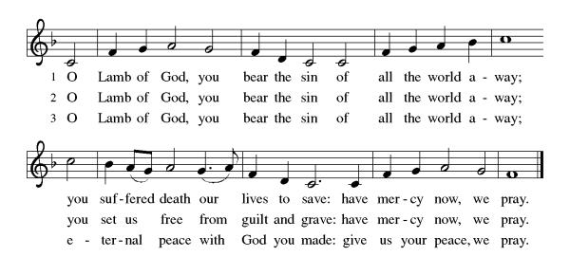

Please be seated
Communion
Communion Distribution
That Priceless Grace ELW 591 By Your Hands, You Feed Your People ELW 469

Anthem Shine on Me arr. W. James Abbington, Jr

Please stand

Communion Blessing

P The body and blood of our Lord Jesus Christ strengthen you and keep you in his grace.
C Amen

Prayer after Communion

P Let us pray,
Sustaining God, with this bread and cup, you nourish us with mercy and abundant life. By your Spirit, send us from this table to serve a needy world. Make us living signs of your liberation, healing, and love,
following the way of Jesus, in whose name we pray.
C Amen.

SENDING
God blesses us and sends us in mission to the world.

Sending Song Soli Deo Gloria ELW 878

Blessing

P The God of love draw you into full accord and one mind,
in the body of Christ Jesus.
C Amen.
P The God of hope grant you strength and joy in all circumstances
through the interceding of the Spirit.
C Amen.

P The God of grace ☩ bless you now and forever.
C Amen.

Dismissal
P Go out in joy. Be led forth in peace.
C Thanks be to God.

Please be seated. It is our tradition here at Lord of Life to be seated during the postlude. If it is your desire to leave, please do so quietly. Thank you.

Postlude A Mighty Fortress Helmut Walcha
Those serving in worship in November
 | 11/01 | 11/08 |  | 11/15 | 11/22 | 11/29
Greeter/Usher | Jeff Dombroski |  | Phyllis Ruse | Gabe West | Zack West | Bob Soles
Lector | Judy McCartney |  | Pastor Mark Williams | Norma Thomas | Diana Williams | Larry Cohol
Counters | Tom Drotleff |  | Tom Drotleff | Tom Drotleff | Tom Drotleff | Tom Drotleff
Altar Guild | Diana Williams |  | Diana Williams | Diana Williams | Norma Thomas | Norma Thomas
Crucifer
Acolyte

Weekly Readings October 26 through October 31, 2026

Mon 10/26 | Tues 10/27 | Wed 10/28 | Thurs 10/29 | Fri 10/30 | Sat 10/31
Psalm 119:  41-48 | Psalm 119:  41-48 | Psalm 119  41-48 | Psalm 43 | Psalm 43 | Psalm 43
Deuteronomy  6: 1-9, 20-25 | Deuteronomy 10:  10-22 | Proverbs 16:  1-20 | 1 Samuel 2:  27-36 | Ezekiel 13:  1-16 | Malachi  1:6-2:9
James 2:  8-13 | James 2:  14-26 | Matthew 19:  16-22 | Romans 2:  17-29 | 2 Peter 2:  1-3 | Matthew  23:13-28


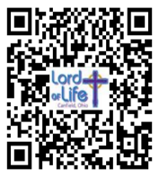
Scan for Online Giving Scan for October Calendar

This Week at Lord of Life

Sunday 9:30 a.m. Kids Time
9:30 a.m. Coffee and Conversation
10:15 a.m. Worship

Monday 6:30 p.m. Madrigal Group
7:00 p.m. Scouts

Tuesday 10:30 a.m. Life Links
1:00 p.m. GriefShare
7:00 p.m. Scouts

Wednesday 10:30 a.m. Bible Study
5:00 p.m. Choir
7:00 p.m. Evening Prayer

Thursday

Friday 10:00 a.m. Morning Prayer

Saturday 5:00 p.m. Saturday Worship

Acknowledgements Copyright and streaming permission given through Sundaysandseasons.com under license #22472 for seasonal texts, prayers scripture readings, ELW Setting 8 (Glory to God, Gospel Acclamation, Holy, Holy, and Lamb of God), Psalm 46. ELW graphics.
ONELICENSE under #A-708717 for A Mighty Fortress organ setting by David Cherwien © 1980 AMSI Publicatios.; A Mighty Fortress Text © 1978 Lutheran Book of Worship, admin. Augsburg Fortress.; In the Singing Text and music © 1996 Hope Publishing Co.; That Priceless Grace Text and arr. © 1999 Augsburg Fortress; By Your Hands You Feed Your People Text and music © 2002 GIA Publications; Shine On Me Choral setting by W. James Abbington, Jr. © 2026 MorningStar Music; Soli Deo Gloria Text and music © 1999 GIA Publications; A Mighty Fortress organ setting by Helmut Walcha © 1954 Henry Litolff’s Verlag, C. F. Peters Corporation,Public Domain: Lord, Keep Us Steadfast in Your Word;

*************************************************************
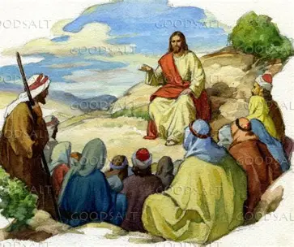

Wednesday Bible Study (10:30 am)
Beginning Wednesday, October 28, 2026

Pastor Mark Williams begins a study on the Sermon on the Mount. Please join us!

*************************************************************

WELCA
Shepherd of the Valley - Boardman
B I N G O!
Wednesday, November 4, 2:00pm
Please consider donating Bingo prizes for the winning residents – Dollar Tree, Dollar General, Family Dollar. Lists of prizes requested are available in the Narthex and will be in the November Servant.
Thank You!

LORD of LIFE LUTHERAN VETERANS

If you are a veteran of the United States military – any branch, and associate with Lord of Life Lutheran Church, please let us know your name, branch of service, and dates served. You do not need to be a registered member of the Church – if you watch the livestream, attend every weekend, or just occasionally, we would like you to let us know about you. Please contact Carol Ryan, at the Church Office, (330) 533-3531, Monday through Friday, 9:00am to 1:00pm, or leave a message at other times. Thank You!


GriefShare Grief Support Group The next session of our GriefShare group started Tuesday, September 15. There are thirteen sessions, and all are on Tuesdays, from 1:00pm to 2:30pm. Please register for the group at GriefShare.org
**************************************************************************

**********************************************************************

COMMITMENT CARDS!
If you did not receive a BRIGHT PINK financial commitment card in the mail this past week, there are several in the Narthex. Please try to have all the cards returned by November 1st so work on the 2027 budget may begin. Thank you for your past and present financial support. You are appreciated!

*************************************************************



