Lord of Life Lutheran Church

A Serving Community
God's work, our hands!
Rev. Rebecca Zielke, Pastor
Tim L. Elder, CAGO, Director of Music

24th Sunday after Pentecost
Sunday, November 8, 2026
10:15 a.m.

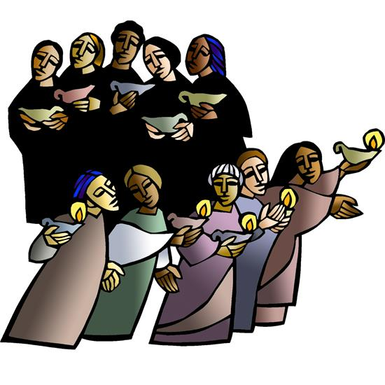
Today the prophet Amos calls for justice to roll down like waters. Paul urges us to encourage one another with the promised coming of the Lord. Jesus tells the parable of the wise and foolish bridesmaids. Surrounded by the faithful of every time and place, we celebrate Christ’s coming in our midst in the word of life and the feast of victory—the marriage feast of the Lamb.

550 North Broad Street 330-533-3531 Canfield, Ohio 44406 e-mail: lordoflife550@gmail.com

Welcome to Lord of Life!
Your presence in our midst is a blessing to us. We hope you find our worship service a prayerful and meaningful experience.

Visitors
If you are visiting with us this weekend, please consider signing our guest book located in our Gathering Space. An usher will be happy to assist you.

Holy Communion
All are welcome to partake in Communion regardless of Christian denomination. Please follow the usher’s direction to come forward to receive the bread from the Pastor and take a glass of wine from the tray. Dispose of the cup in the basket provided on the altar railing and return to your seat by the side aisle. Gluten free hosts are available upon request.

Worship notes
“ELW” refers to our hymnbook “Evangelical Lutheran Worship” which is the red hymnbook in the pew racks. Other hymns that may be included in our worship service, that do not appear in ELW, will be directly printed into the bulletin.

All items in bold print are responses spoken by the assembly.

Worship bulletin key: P = Pastor, L = Lector, C = Congregation.
Any other specific directions are notated in red throughout the bulletin.

The offering plate is located as you enter the worship space.

Restrooms
There are two sets of restrooms located in our building. The first, and closest, are found by exiting the sanctuary and turning to your right, down the hallway toward the coat room, and then turning right once again.
The second set, is located by exiting the sanctuary, turning right down the hallway toward the coat room and then turning left. Walk all the way down to the end of the hallway and they are located on your left

GATHERING
The Holy Spirit calls us together as the people of God.
Announcements
Prelude Deep River setting by Wilbur Held

Please stand as you are able.
Confession and Forgiveness
All may make the sign of the cross, the sign that is marked at baptism, as the presiding minister begins.
P Blessed be the holy Trinity, ☩ one God,
our dwelling place for all generations,
whose compassion never slumbers.
C Amen.

Let us confess our sin in the presence of God
and of one another.

Holy God,
C we confess that we have trusted in our preparation
instead of your invitation.
We prioritize our piety over care for your beloved.
We trust the voice of our shame and fear,
which keeps us from entering fully
into relationship with you and others.
We are not awake to the coming of your reign.
Rouse us and rescue us,
that we may enter into your joy.
Amen.

P Inherit the riches of God’s grace.
☩ Jesus, the good shepherd, feeds you with his mercy.
You are forgiven.
Blessed are you.
C Amen.

Gathering Hymn Oh, Happy Day When We Shall Stand ELW 441
Greeting
P The grace of our Lord Jesus Christ, the love of God and the communion of the Holy Spirit be with you all.
C And also with you.

Glory to God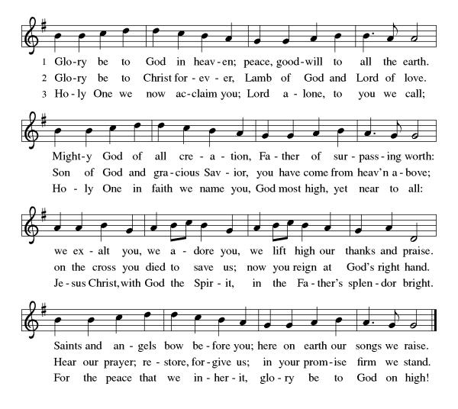

Prayer of the Day
P Let us pray,
O God of justice and love, you illumine our way through life with the words of your Son. Give us the light we need, and awaken us to the needs of others, through Jesus Christ, our Savior and Lord.
C Amen

Please be seated
WORD
God speaks to us in scripture readings, preaching and song.

First Reading Amos 5:18-24
In the days of Amos, people thought that the day of the LORD would be a time of great victory, but Amos announced that it would be a day of darkness, not light. He said liturgy is no substitute for obedience. The LORD demands justice and righteousness in the community.

¹⁸ Woe to you who desire the day of the Lord!
Why do you want the day of the Lord?
It is darkness, not light,
¹⁹ as if someone fled from a lion
and was met by a bear
or went into the house and rested a hand against the wall
and was bitten by a snake.
²⁰ Is not the day of the Lord darkness, not light,
and gloom with no brightness in it?
²¹ I hate, I despise your festivals,
and I take no delight in your solemn assemblies.
²² Even though you offer me your burnt offerings and grain offerings,
I will not accept them,
and the offerings of well-being of your fatted animals
I will not look upon.
²³ Take away from me the noise of your songs;
I will not listen to the melody of your harps.
²⁴ But let justice roll down like water
and righteousness like an ever-flowing stream.

L Word of God, word of life.
C Thanks be to God.

Psalm 70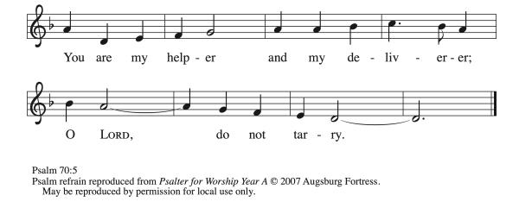
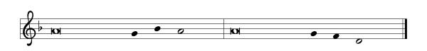

¹ Be pleased, O God, to de- | liver me;
O Lord, make | haste to help me.
² Let those who seek my life be put to shame | and confounded;
let those who take pleasure in my misfortune draw back and | be disgraced. R
³ Let those who say to me “Aha!” and gloat | over me
turn back because | of their shame.
⁴ Let all who seek you rejoice and be | glad in you;
let those who love your salvation say forever, “Great | is the Lord!”
⁵ But as for me, I am poor and needy; come to me quick- | ly, O God.
You are my helper and my deliverer; O Lord, | do not tarry. R

Second Reading 1 Thessalonians 4:13-18
Some of the Thessalonians are worried that dead Christians will be excluded from the resurrection to eternal life when Christ comes again. Paul reassures them with the word of hope that all Christians, living or dead, will be raised into everlasting life with Christ.

¹³ We do not want you to be uninformed, brothers and sisters, about those who have died, so that you may not grieve as others do who have no hope. ¹⁴ For since we believe that Jesus died and rose again, even so, through Jesus, God will bring with him those who have died. ¹⁵ For this we declare to you by the word of the Lord, that we who are alive, who are left until the coming of the Lord, will by no means precede those who have died. ¹⁶ For the Lord himself, with a cry of command, with the archangel’s call and with the sound of God’s trumpet, will descend from heaven, and the dead in Christ will rise first. ¹⁷ Then we who are alive, who are left, will be caught up in the clouds together with them to meet the Lord in the air, and so we will be with the Lord forever. ¹⁸ Therefore encourage one another with these words.

L Word of God, word of life.
C Thanks be to God.

Please stand
Gospel Acclamation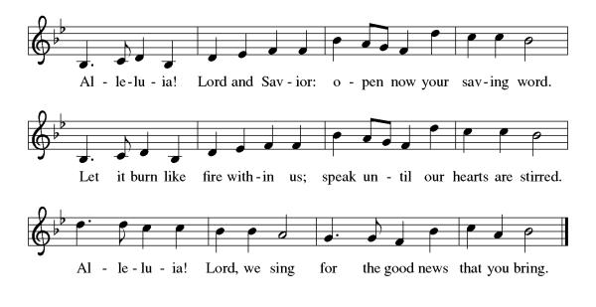

Gospel Matthew 25:1-13
Jesus tells a parable about his own second coming, emphasizing the need for readiness at all times.

P The holy gospel according to Matthew.
C Glory to you, O Lord.

[Jesus said to the disciples:] ¹ “Then the kingdom of heaven will be like this. Ten young women took their lamps and went to meet the bridegroom. ² Five of them were foolish, and five were wise. ³ When the foolish took their lamps, they took no oil with them, ⁴ but the wise took flasks of oil with their lamps. ⁵ As the bridegroom was delayed, all of them became drowsy and slept. ⁶ But at midnight there was a shout, ‘Look! Here is the bridegroom! Come out to meet him.’ ⁷ Then all those young women got up and trimmed their lamps. ⁸ The foolish said to the wise, ‘Give us some of your oil, for our lamps are going out.’ ⁹ But the wise replied, ‘No! there will not be enough for you and for us; you had better go to the dealers and buy some for yourselves.’ ¹⁰ And while they went to buy it, the bridegroom came, and those who were ready went with him into the wedding banquet, and the door was shut. ¹¹ Later the other young women came also, saying, ‘Lord, lord, open to us.’ ¹² But he replied, ‘Truly I tell you, I do not know you.’ ¹³ Keep awake, therefore, for you know neither the day nor the hour.”

P The gospel of the Lord.
C Praise to you, O Christ.

Please be seated.
Children’s Message
Sermon
Please stand as you are able.
Hymn of the Day Rejoice, Rejoice Believers ELW 244

Apostles’ Creed
I believe in God, the Father almighty, creator of heaven and earth.
I believe in Jesus Christ, God's only Son, our Lord, who was conceived by the Holy Spirit, born of the virgin Mary, suffered under Pontius Pilate, was crucified, died, and was buried; he descended to the dead. On the third day he rose again; he ascended into heaven, he is seated at the right hand of the Father, and he will come to judge the living and the dead.
I believe in the Holy Spirit, the holy catholic church, the communion of saints, the forgiveness of sins, the resurrection of the body, and life
everlasting. Amen

Prayers of Intercession
P United with the great cloud of witnesses, we offer our prayers for the church, the world, and all of creation.

A brief silence.

You illumine the church with the hope of your new day. Prepare our hearts and minds for the inbreaking of your kingdom, that we might awaken to your transforming love at work all around us. God, in your mercy,
C hear our prayer.

P You create and sustain the earth’s natural rhythms so that all life might thrive. Show us the wisdom and wonder of nature’s balance; make us careful stewards of our common home. God, in your mercy,
C hear our prayer.

P You make justice roll down in all places and among all nations. Encourage all who protect vulnerable communities and help rebuild in the aftermath of conflict. Uphold veterans and those who care for them. God, in your mercy,
C hear our prayer.

P You hasten to heal our wounds and make whole what is broken. Comfort individuals facing a difficult diagnosis, receiving palliative care, or facing uncertain treatment options. We especially pray for those that we name out loud or in our hearts.
Delores Bailey, Laurel Froelich, Dr. Ronald Gould, Chris Hunnicutt,
Michael Jacques, Sean Kelly, Daryl Kirtley, Devon Kirtley, Todd Kirtley, Tami Kuhlmann, George Lange, Joye Lange, Craig Miller, Marge Pancher, Frank Scott, Bob Titus, David Titus, Pearl Torrence, and Debbie Williams.
(The names on the prayer list are updated every 30 days. If you wish to continue to have someone on the list, please contact the office.)

God, in your mercy,
C hear our prayer.

P You give rest to weary hearts and bodies. As the days grow shorter in the north, help us to move more slowly and intentionally through our days, honoring the need for quiet and stillness. God in your mercy,
C hear our prayer

P You welcome those who have come before us in faith into the joys of heaven. Sustain us by your grace and guide us into the promise of everlasting life. God, in your mercy
C hear our prayer

P Into your steadfast love, faithful God, we entrust all for whom we pray, in the name of Jesus, your beloved.
C Amen

Peace

P The peace of Christ be with you always.
C And also with you.

Please be seated.
The offering plate is located on the table as you enter/exit the worship space.

MEAL
God feeds us with the presence of Jesus Christ.

Offering Response We Plow the Fields and Scatter ELW 681

Please stand.

Offering Prayer

P Let us pray,
Eternal God, our time, talents, and treasures are gifts from you.
Receive what we offer, and all that you entrust to us, until hungry no more, all the world is fed. through Jesus Christ, our Savior and Lord.
C Amen.

Dialogue
P The Lord be with you.
C And also with you.

P Lift up your hearts.
C We lift them to the Lord.

P Let us give thanks to the Lord our God.
C It is right to give our thanks and praise.

Preface
P It is indeed right, our duty and our joy, …
...we praise your name and join their unending hymn:

Holy, Holy,
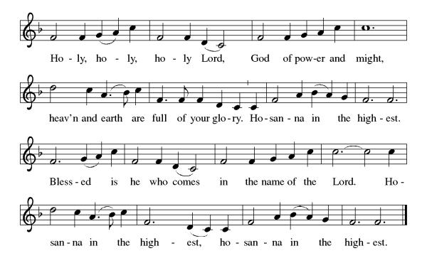
Eucharistic Prayer

P Holy, mighty, and merciful Lord, heaven and earth are full of your glory.
In great love you sent us to Jesus, your Son, who reached out to heal the sick and suffering, who preached good news to the poor, and who, on the cross, opened his arms to all.

In the night in which he was betrayed, our Lord Jesus took bread, gave thanks: broke it, and gave it to his disciples, saying: Take and eat; this is my body, given for you. Do this for the remembrance of me.

Again, after supper, he took the cup, gave thanks, and gave it for all to drink, saying: This cup is the new covenant in my blood shed for you and for all people for the forgiveness of sin. Do this for the remembrance of me.

Remembering, therefore, his death, resurrection, and ascension, we await his coming in glory.

Pour out upon us the Spirit of your love, O Lord, and unite the wills of all who share this heavenly food, the body and blood of Jesus Christ our Lord; to whom, with you and the Holy Spirit, be all honor and glory, now and forever.
C Amen

Lord's Prayer

C Our Father, who art in heaven, hallowed be thy name, thy kingdom come, thy will be done, on earth as it is in heaven. Give us this day our daily bread. and forgive us our trespasses, as we forgive those who trespass against us; and lead us not into temptation but deliver us from evil. For thine is the kingdom, and the power, and the glory, forever and ever. Amen.

Invitation to Communion
P In bread and cup the reign of Christ is breaking in.
Come, receive what Christ has prepared.

Lamb of God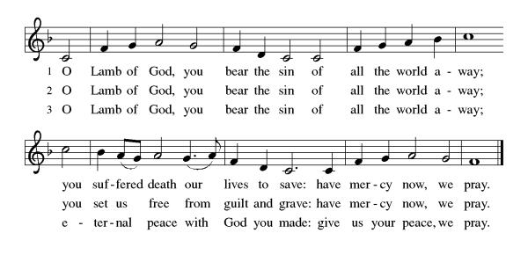
Please be seated
Communion
Communion Distribution
When Peace Like a River ELW 785 When Long Before Time ELW 861

Anthem Keep Your Lamps

Please stand

Communion Blessing

P The body and blood of our Lord Jesus Christ strengthen you and keep you in his grace.
C Amen

Prayer after Communion

P Let us pray,
Holy God, we have received your never-ending mercy in this meal. You continuously seek the lost, bind the injured, and feed your people abundantly.
Now send us out, awake to your presence, now and forever.
C Amen.

SENDING
God blesses us and sends us in mission to the world.

Sending Song Blessed Assurance ELW 638

Blessing

P The holy Trinity,
Father, ☩ Son, and Holy Spirit, bless you with wisdom to welcome the reign of God, today and always.
C Amen.

Dismissal
P Go in peace. Encourage one another.
C Thanks be to God.

Please be seated. It is our tradition here at Lord of Life to be seated during the postlude. If it is your desire to leave, please do so quietly. Thank you.

Postlude Blessed Assurance J. Bert Carlson
Acknowledgements Copyright and streaming permission given through Sundaysandseasons.com under license #22472 for seasonal texts, prayers scripture readings, ELW Setting 8 (Glory to God, Gospel Acclamation, Holy, Holy, and Lamb of God), Psalm 70. ELW graphics.
ONELICENSE under #A-708717 for Deep River organ setting by Wilbur Held © 1986 Augsburg Publishing House; Oh, Happy Day When We Shall Stand © 1958, 1978 Augsburg Fortress; Keep Your Lamps choral setting by Andre Thomas © 1982 Hinshaw Music; When Long Before Time Text and tune © Peter W. A. Davison, admin. Augsburg Fortress, arr. © George Black; Blessed Assurance organ setting by J. Bert Carlson arr. © 2001 Augsburg Fortress.
Public Domain: Rejoice, Rejoice Believers; We Plow the Field and Scatter; When Peace Like a River; Blessed Assurance.
.
Those serving in Worship in November
 | 11/01 | 11/08 | 11/15 | 11/22 | 11/29
Greeter/Usher | Jeff Dombroski | Phyllis Ruse | Gabe West | Zack West | Bob Soles
Lector | Judy McCartney | Pastor Mark Williams | Norma Thomas | Diana Williams | Larry Cohol
Counters | Tom Drotleff | Tom Drotleff | Tom Drotleff | Tom Drotleff | Tom Drotleff
Altar Guild | Diana Williams | Diana Williams | Diana Williams | Norma Thomas | Norma Thomas
Crucifer
Acolyte

Weekly Readings November 07th through November 14th

Mon  11/09 | Tues  11/10 | Wed  11/11 | Thu  11/12 | Fri  11/13 | Sat  11/14
Psalm 63 | Psalm 63 | Psalm 63 | Psalm 90:  1-8 [9-11]12 | Psalm 90:  1-8[9-11]12 | Psalm 90:  1-8[9-11]12
Amos 8:7-14 | Joel 1:1-14 | Joel 3: 9-21 | Ezekiel 6:  1-14 | Ezekiel 7:  1-9 | Ezekiel 7:  10-27
1 Corinthians 14:  20-25 | 1 Thessalonians 3: 6-13 | Matthew 24:29-35 | Revelation 16: 1-7 | Revelation 16: 8-21 | Matthew 12: 43-45

Scan for Online Giving Scan for November calendar
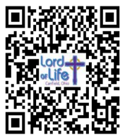


This Week at Lord of Life

Sunday 9:30 a.m. Kids Time
9:30 a.m. Coffee and Conversation
10:15 a.m. Worship
11:30 a.m. Confirmation Class

Monday 6:30 p.m. Madrigal Group
6:00 p.m. Social Statement Discussion
7:00 p.m. Scouts

Tuesday 10:30 a.m. Life Links
1:00 p.m. GriefShare
7:00 p.m. Scouts

Wednesday 10:30 a.m. Bible Study
5:00 p.m. Choir
7:00 p.m. Evening Prayer
Thursday

Friday 10:00 a.m. Morning Prayer

Saturday 9:00 a.m. Council Budget Worship
5:00 p.m. Saturday Worship


Cluster-Wide study on “Faith and Civic Life”
Pastor Becky is leading a study on the social statement approved by the 2025 Church-wide Assembly called “Faith and Civic Life,” on six Mondays, 6:00-7:30pm, in the Adult Sunday School Room. The study is open to all Mahoning County Lutheran Cluster Churches.
*************************************************************************************

GriefShare Grief Support Group
Our GriefShare group started Tuesday, September 15. There are thirteen sessions, and all are on Tuesdays, from 1:00pm to 2:30pm. Please register for the group at GriefShare.org

THE GATHERING PLACE SENIOR CENTER EVENT

Monday, November 9th, 11:00am Lord of Life Lutheran Church 550 North Broad St, Canfield, Oh 44406
This is a free, community outreach social program offered to all senior citizens, held on the second Monday of each month. Our Guest: Ginger Manji, Local Historian, speaking on historical quilts, including a Presidential quilt, a Republican and a Democrat.

Lord of Life YouTube Channel!
Don’t forget to subscribe to the Lord of Life YouTube channel! Each week, Pastor Becky posts a video called “Or This.” In this series, Pastor Becky explores thoughts and ideas that didn’t make it into the Sunday sermon and invites you to share your thoughts about the Scriptures, sermon or video in the Comments. The “Or This” videos are also shared to the Lord of Life Facebook Page and Group.
********************************************************

Thank you to everyone who submitted Commitment Cards for 2027!

In late November you will receive the 2027 Proposed Budget for Lord of Life in the mail. Mark your calendar to join us after worship on Sunday, December 6th, for the Annual Congregational Meeting, when we will vote on the budget and on council members for 2027.
********************************************************

Lord of Life Book Club
“Between the Lines” Update
Please plan to join us. A time for fellowship and good discussions on assigned books.

A CHANGE in SCHEDULING
Henceforth, instead of Saturdays, we have changed gatherings to the Third Monday of each month at 10:00am.

FORTHCOMING READINGS
November 23- “West with Giraffes” by Lynda Rutledge
December 21- “The Red Bird Christmas” by Fannie Flagg

********************************************************


Wednesday Bible Study (10:30 am)
Pastor Mark Williams continues a study on the Sermon on the Mount. Please join us!

********************************************************
*************************************************************
MADRIGAL CONCERT and BOARS HEAD FESTIVAL

Please join us on Saturday, December 12th, 2:00pm at Martin Luther Lutheran Church, 420 Clearmount Drive, Youngstown. The program will include Renaissance music from the 14th to the 16th centuries, and includes many familiar Christmas tunes. Please bring a covered dish for our potluck Boars Head Dinner. No need to say what you are bringing, just bring something to share. The performance is free and open to the public. Please join us for an afternoon of sacred and festive songs and instrumental music. Presented by the Tapestries of Ohio Madrigal Singers.

********************************************************

LORD of LIFE LUTHERAN VETERANS

If you are a veteran of the United States military – any branch, and associate with Lord of Life Lutheran Church, please let us know your name, branch of service, and dates served. You do not need to be a registered member of the Church. Please contact Norma Pignanelli (330) 717-0981, or visit the sign-up sheet in the Narthex. Thank You!

********************************************************

